|  |  |
| --- | --- |
|  | **Faculty of Computer Science and Information Technology** |

**Road Assistant GP**

**Submitted by:**

* **Zain Alabedin Moaz 41810258**
* **Ramez Ashraf 41810232**
* **Youssif Hany 41810226**
* **Mohamed Tantawy 41810129**
* **Osman Hashem 41810176**
* **Mohamed Badr 41810297**

**A dissertation submitted in partial fulfillment of the requirements for the degree of Bachelor of computer science and information technology**

**Supervised by:**

**Dr. Shady Mohamed El-Said**

****

**Egypt 2022**

**Committee Report**

We certify we have read this graduation project report as examining committee, examine the student in its content and that in our opinion it its adequate as a project document for “Road Assistant”.

***Chairman: Supervisor:***

Name: Prof. Ehab Talkhan Name: Dr. Shady Mohammed

Signature: Signature:

Date: 3/7/2022 Date: 3/7/2022

***Examiner:***

Name: Dr. Ahmed Saif

Signature:

Date: 3/7/2022**Intellectual Property Right Declaration**

This is to declare that the work under the supervision of Dr. Shady Mohammed Elsaid having title “Road Assistant” carried out in partial fulfillment of the requirements of Bachelor of Science in Computer Science and Information Technology is the sole property of the Ahram Canadian University and the respective supervisor. It is protected under the intellectual property right laws and conventions. It can only be considered/ used for purposes like extension for further enhancement, product development, adoption for commercial/ organizational usage, etc. with the permission of the university and respective supervisor. This above statement applies to all students and faculty members.

Names:

Supervisor:

**Anti-Plagiarism Declaration**

This is to declare that the above publication produced under the supervision of Dr. Shady Mohammed Elsaid having title " Road Assistant” is the sole contribution of the author(s) and no part hereof has been reproduced illegally (cut and paste) which can be considered as Plagiarism. All referenced parts have been used to argue the idea and have been cited properly. We will be responsible and liable for any consequence if violation of this declaration is proven.

Names:

**Table of Contents**

Acknowledgement

Abstract

Table of contents

**Chapter 1: introduction 7**

1.1 Overview 7

1.2 Motivation 7

1.3 Problem Definition 8

1.4 Objective 10

1.5 Aim 10

**Chapter 2 Background and Previous work 11**

2.1 Background 11

2.2 Previous work 11

**Chapter 3 planning and analysis 13**

3.1 Feasibility study and estimated cost 13

3.1.1 Feasibility test 14

3.1.2 Technical feasibility 14

3.1.3 Functional feasibility 14

3.1.4 Time feasibility 14

3.1.5 Methodology 15

3.2 Need for new system 15

3.3 Analysis of new system 15

3.3.1 User Requirements 15

3.3.2 System Requirements 16

3.3.3 Functional Requirements 16

3.3.4 Non- Functional Requirements 16

3.4 User characteristics 17

**Chapter 4:** **design 18**

4.1 Overview 18

4.2 System study 18

4.2.1 What is the system 18

4.2.2 Elements of the system 18

4.3 System planning and investigation 19

4.4 Object-Oriented analysis 19

4.4.1 What is UML? 19

4.4.2 Relation between UML and Object-Oriented analysis design 20

4.5 ER diagram 20

4.6 Class diagram 23

4.7 Use case diagram 26

4.7.1 Use-case Scenarios 27

4.8 Activity diagram 29

4.9 Sequence and Communication diagram 31

4.10 Deployment Diagram 37

4.11 State diagram 40

**Chapter 5: Implementation 42**

5.1 User Interface and Applications used 42

5.2 Results and Discussion 62

**Chapter 6: Testing 63**

6.1 Unit Testing 63

**Conclusion** 68

**Future work 68**

**Chapter 1: Introduction**

## houston-pothole-damageOverview

Roads can deteriorate to the level where they become dangerous. This includes potholes, uneven road surfaces, broken concrete, exposed rebar, sinkholes, and road cracks. These days, there are many accidents on the roads due to these road defects and the driver's lack of knowledge about them. For example, if a driver hits a large pothole, it could burst the tire causing the vehicle to veer into another lane, colliding with another vehicle.

They can also affect most parts of the car negatively and endanger the car in the event of driving especially in the night, because these bumps and potholes doesn’t appear until late in the car.

Damage caused by bumps to your car If you are driving your car at a very high speed, and you are surprised by the presence of a bump that you did not consider, your car may be exposed to many damages that you did not expect, including Damage to bumps in your car.

Road anomalies can lead to serious traffic accidents. For example, between 2000 and 2011, there were 2 million traffic accidents in Canada, of which 33% were related to road conditions or bad weather. In 2019, the Central Agency for Public Mobilization and Statistics (CAPMAS) in Egypt announced increase in car accidents compared to 2018 by 17.8%. In 2015, about 50,000 British drivers were involved in traffic accidents caused by road anomalies, and road pits caused a car accident every 11 min. As a result, governments spend huge amounts of manpower and resources on road maintenance. The British 3

Toronto, Canada spent a total of $6 million on road repairs.4 Therefore, detecting road anomalies in an efficient and simple way is helpful to reduce the expense and improve efficiency of road repairs.

## Motivation

we need in our daily life software that can automatically detect and upload the location of the defects with a picture of them so the driver could avoid it and decrease the accidents on the road, also the ministry of transportation and public authority of roads to fix them. Road deterioration has always been a public annoyance, causing passenger discomfort, damage to vehicles, and sometimes may even lead to accidents. Bumps destroy your steering: When bumps can`t protect your car, the rest of the parts in your car will pay the price, as the constant vibrations in the road damage other vital systems inside the car, especially the steering wheel, and you will lose control of your car`s steering while driving. Bumps destroy your exhaust system: Exhaust systems are designed directly at the bottom of the car, so that the exhaust does not make an annoying sound while driving, and so that your vehicle is more efficient and environmentally friendly, but if you exceed the speed limit too much; This will easily damage the exhaust system, Furthermore, road maintenance should be preceded by road inspection process needed for assigning priorities for the roads to be repaired according to the urgency of their defects.

The motivation behind our proposed system is that it will boost the road infrastructure development process through the database we aim to build which will facilitate inspection and scheduling processes saving effort and time. As this database can then be retrieved by a developed mobile application to enable the concerned civic authorities to easily and quickly identify damaged roads and prioritize roads to be repaired according to their quality. As for the vehicle’s drivers, we can represent these data through maps. These road quality maps will enable the end-users to navigate through roads previewing their quality to choose the best route for destination, if possible. Also, it may serve as a warning system to alert drivers before any upcoming road defect they may encounter on their path while driving to avoid it until these roads are repaired. This database can also be integrated into other mobile applications such as (Google Maps) to provide users with some additional features as mentioned before. Thus, we can provide drivers more safe and comfortable rides, reducing the damage the vehicles are exposed to and reducing road-related accidents as well. Furthermore, we can add another feature to enable citizens to easily complain about any road defect that caused any sort of damage to them. On the other hand, the road authorities will receive these complaints and it will be taken into consideration during the scheduling phase. And thus, reducing the gap between citizens and road authorities.

## Problem Definition

Nowadays, deterioration of road infrastructure including roads, bridges, and tunnels is one of the prevailing serious problems afflicting countries all over the world. We all suffer daily from road surface defects such as potholes and cracks formed due to traffic overloading, environmental conditions and aging of roads. Moreover, they are a major contributing factor to traffic accidents leading to injuries, loss of lives and damage to vehicles as well. Thus, regular road inspection and maintenance is urgently required to ensure that the requirements for road safety, efficiency and durability are satisfied to save citizens life and to make a nation grow and develop. Hence, to develop proper effective road infrastructure maintenance strategies, a systematic approach to know road condition is a prerequisite to determine which roads need to be repaired first and to allocate limited maintenance resources for them.

Typically, road condition assessment procedures are performed by certified inspectors and structural engineers, either performed manually onsite or semiautomated by analyzing images obtained using cameras mounted on some cars. However, it is difficult for the government to maintain a regular surveillance on the entire road network conditions relying on the traditional manual approach for road defects detection, which is time-consuming, labor-intensive, and expensive. The manual visual inspections are also known to be subjective which might result in unreliable evaluation of road condition. Considering this issue in road infrastructure maintenance and management, municipalities and road authorities seek to find an efficient sophisticated solution to automate the process of road network evaluation. Meanwhile, the vehicles drivers are seeking a way to enable them to choose the best route (quality-wise) to their destination and to be aware about any upcoming defects before they drive over them. In order to maximize the benefit of our project and making sure that it is needed in real life, consistent with available business problems, and will actually help with the problems that pop up due to the lack of development of roads, we had conducted a survey to demonstrate how people are affected by this real-life problem and here are some of the results:



*Figure 1-1: Survey Question – 1*

**

*Figure 1-2: Survey Question – 2*

**

*Figure 1-3: Survey Question - 3*

4

**From people’s comments:**

- Please make everything you can to improve the highways and streets in the city to

avoid accidents and car’s problems

- Thanks for caring about this irritating case & I really hope there will be a solution

to it.

- I hope this project will have a great influence upon different routes (later on).

God be with you.

- Google maps help to avoid traffic and the long ways

## Objective

Our objective is to is to build a road damage database so that drivers avoid them and take caution and to maintain the safety of cars and reduce accidents on the roads and to make it easier for the government and the General Authority for Roads to identify the locations of defects on the roads and to fix them and improve the road quality.

Build a mobile application make use of this database by the normal user, where user can view the defects through the mobile application. In addition, user can also do a manual report for undetected defects on the road and it will automatically be sent to the database and be viewed on maps.

## Aim

We propose a computer vision-based system for real-time detection, classification, and localization of road surface defects such as potholes and cracks. As we aim to develop a system to automate the road inspection process, there are many benefits from this application, it’s very helpful a lot of people that are driving through the road as they may not know the defects in it. Our application will have plenty of useful functions, such as:

1. Cameras that can detect road defects.
2. Databases that are automatically updated.
3. Users that can deal with the database thought mobile application.
4. Alerts the user about road defects.
5. The application views all defects that been updated to the database
6. **System Usability**

To reach a level of usability that satisfies the end-user that uses the system, taking care of UI (User Interface) which is the first thing to attract the user and then UX (User Experience) which makes the user love to use the system because of the ease of use.

1. **System Efficiency**

To establish a powerful system that works efficiency in the back-end that the user does not see but feel it, an efficient system is a fast, reliable and an interactive system.

**Chapter 2: Background & Previous work**

## Background

Nowadays high-speed data acquisition techniques lead to large amount of data sets that need to be transformed into relevant information. However, the necessary results such as road conditions are obtained manually from the point cloud or 360-degree images.

Road defects are one of the most common reasons for suspension repairs and tire replacements. According to general statistics, even the most careful drivers face suspension repairing every three years or so. Bad roads are a well-known issue in most countries.

Our project is based on a machine learning model that makes the driving experience a lot easier by detecting the road deficiencies and reporting them back through a mobile application. Although the model is used separately from the mobile application, both of them are connected on the same cloud to retrieve the necessary data.

There are a vast number of pre-made machine learning models for object detection and classification trained by Google and Facebook. Unfortunately, there were no pre-made models for pothole detection. This way we decided to train a custom model from scratch.

## Previous Work

|  |  |
| --- | --- |
| * **Porsche**   Porsche adds feature in their new released cars (4/2021), that help the car owner to avoid the road defects by giving an alert when the car detects a defect on the road (potholes, cracks, damaged bumps, etc..), by using a camera at the front of the car, but its only useful for Porsche Owners and not for everyone. | 45326-Sticker-Porsche-Logo  Porsche |
| * **Google maps**   Google Maps  has many features including [turn-by-turn navigation](https://en.wikipedia.org/wiki/Turn-by-turn_navigation" \o "Turn-by-turn navigation), [street view](https://en.wikipedia.org/wiki/Street_view" \o "Street view), and public transit information and user manually add if there was a defect on the road. As we are the users, its rarely to stop while driving a car to report for a road defect. | pngwing.com      Google maps |
| * **Pbctoday**   A new collaborative project between Road Intelligence Ltd, Construction Scotland Innovation Centre (CSIC) and the University of Edinburgh could lead to an app that predicts potholes before they happen. | pbctoday-logo-02-retina  PBC Today |
| * **Smartphone Sensing of Road Surface Condition and Defect Detection**   Road surface condition is vitally important for road safety and transportation efficiency. Conventionally, road surface monitoring relies on specialized vehicles equipped with professional devices, but such dedicated large-scale road surveying is usually costly, time-consuming, and prohibitively difficult for frequent pavement condition monitoring—for example, on an hourly or daily basis. Current advances in technologies such as smartphones, machine learning, big data, and cloud analytics have enabled the collection and analysis of a great amount of field data from numerous users (e.g., drivers) whilst driving on roads. In this regard, we envisage that a smartphone equipped with an accelerometer and GPS sensors could be used to collect road surface condition information much more frequently than specialized equipment. | Sensors  ezgif-4-2d658318b397    Output of a model using sensors |
| * **Road defects detection by machine learning**   To automate manual work of operators who search and select road defects from road laboratories video footage, like cracks, holes and patches.   * Software for creating training set of defects * Near real time algorithm for quick detection of defects from video   As they say, there are two major problems in Russia, and one of them are bad roads. According to Wikipedia, the total length of Russia's road network [is 1,396,000 km](https://ru.wikipedia.org/wiki/%D0%90%D0%B2%D1%82%D0%BE%D0%BC%D0%BE%D0%B1%D0%B8%D0%BB%D1%8C%D0%BD%D1%8B%D0%B5_%D0%B4%D0%BE%D1%80%D0%BE%D0%B3%D0%B8_%D0%A0%D0%BE%D1%81%D1%81%D0%B8%D0%B8" \t "_blank). Russia is ranked fifth in the world by length of the road network. Given that and the fact that climatic conditions are not always favorable, the task of maintaining the good condition of the entire road network in Russia is a non-trivial. It is important to understand that the problem requires a systemic solution. Investing in a large number of disparate repairs — it is a struggle with the symptoms rather than treating the disease. |  |
| * **Road defect detection using deep active learning**   They relied on MC-Dropout (Gal et al.) and BALD (Houlsby et al.) to estimate the uncertainty of each unlabeled sample. their model is a U-Net (Ronneberger et al.), to which we added a Dropout layer before the last convolution. This Dropout layer allows us to use MC-Dropout (more on that later). We trained our network using standard weighted cross-entropy. The weights are automatically detected by the proportion of pixels per class at each active learning step.  MC-Dropout is a technique proposed by Gal et al. in which they estimate the posterior distribution of the model using Dropout, and BALD is a heuristic that can be used with MC-Dropout to quantify the uncertainty of a distribution. |  |
| * **Road Doctor Laser Scanner**   project for road network inspection which relies on laser scanning approach. As shown in the opposite figure, they’ve designed a special car equipped with many expensive hardware components for that purpose. |  |

**Chapter 3: Planning & Analysis**

## Feasibility study and estimated cost

* What if the System wasn’t implemented?
* Car drivers will not notice the defects on the road and it will cause damage to the car.
* What is the current process problem?
* Our road contains a lot of potholes and cracks.
* How will the system help?
* 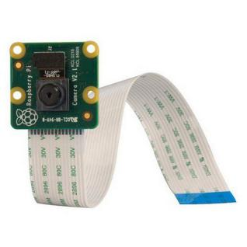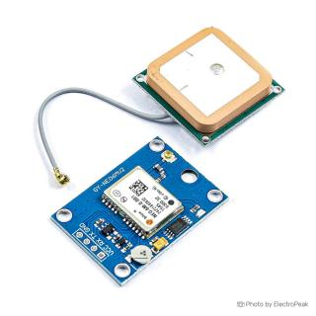People will know the road quality before heading into it and avoid every defect on the road This will reduce road accidents and car damage.
* Hardware Requirements
* Raspberry Pi 4 B
* Raspberry Pi camera
* GPS module (neo 6m)
* Display Screen for raspberry Pi
* 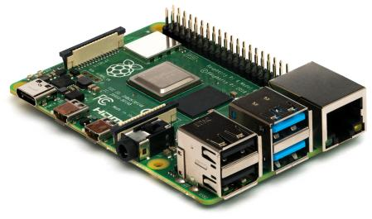Software Requirements
* raspberry Piimager
* Raspberry Pi Os (Raspbian 64)
* XCode
* Collab
* Firebase

The proposed software and mobile application will help the user to know the places of the defects, anyone who got a smartphone can use the app and see the road quality, and get to his destination easily and increased user satisfaction. This application should be easy to use, easy to understand, and updated with new features. The aim of the project is to make the road defects (potholes, cracks) more visible to the people, as we know that thousands of accidents happen because of the bad quality of the road, and the large numbers of cracks and potholes, these defects cause a lot of damage to cars, that cost the owner a lot of money on fixing it, also it causes accidents and sometimes leads to death. This Software and Mobile Application as we said at the past paragraph will make potholes and cracks more visible by capturing an image and the location of the defect and automatically uploaded to the database which will be implemented in the mobile Application where the user can see the defect before reaching, also can see the whole rout quality before starting the trip. In any project there must be an important goal served for the customers so in order to achieve this goal we must know two things. First, what we are going to do?

Second, is the system can be done? And that’s the most important thing because what is the benefit of a good Application not all the users can use? So, the user’s environment must be studied carefully to make a system that is useful for most of the users.

* + 1. **Feasibility Test**

` The problem is analyzed and feasibility study is also performed for making sure that it is feasible for creating such a web site. The feasibility report is created and mainly three types of feasible studies are performed which are Technical Feasibility, Functional Feasibility, and Time Feasibility.

* + 1. **Technical Feasibility**

Technical feasibility centers on the existing computer and to what extend it can support the proposed addition. In technical feasibility both software and hardware feasibilities are checked. In the case of hardware, the created software can be executed on any configurations in which Microsoft windows operation system works.

* + 1. **Functional Feasibility**

All functional and non-functional requirements have been analyzed. Functional requirements are the one the minimum things the system should support. Nonfunctional requirements are mainly to avoid external events that can affect the system performance. The proposed system is beneficial only if they can be turned into information system that will meet the organization ‘s functional requirements

* + 1. **Time Feasibility**

Will the proposed project be completed within the stipulated time frame? effectively? As the analysis shows, the project has a scope for a long period of time. The stipulated time for this project is three months and it can be completed within span of time. The system is judged feasible. Viewing the collected information, recommendation and justification, conclusions is made of the proposed system.

* + 1. **Methodology**

SDLC, Software Development Life Cycle is a process used by software industry

to design, develop and test high quality software. The SDLC aims to produce high

quality software that meets or exceeds customer expectations, reaches completion within

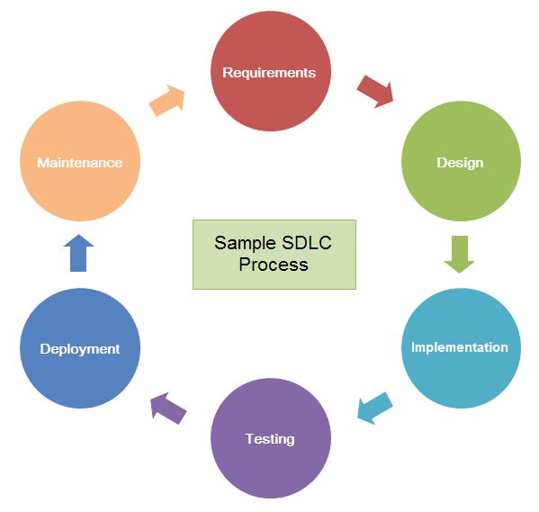times and cost estimates.

The main function of a lifecycle model is to establish the order in which a project

specifies, prototypes, designs, implements, reviews, tests, and performs its other

activities. It establishes the criteria that you use to determine whether to proceed from

one task to the next.

SDLC, can be divided to 6 phases which are listed below:

1. Requirement gathering and analysis,
2. Design,
3. Implementation and coding,
4. Testing,
5. Deployment, and
6. Maintenance.
   1. **Need for new system**

It describes the renewal that the Application will achieve. this Application adds new features like the idea of purposed Application. Now let’s know what the proposed Application will add: -

* 1. User don’t know the quality of the road until he takes the road
  2. User can’t know the exact place of the defect on the road until he sees it
  3. User can’t let others know the place of the defect until he reports it manually
  4. **Analysis for new system**
     1. User Requirements

User requirements are typically written when discussing the use cases for a project. The requirements definition is done with the customer or product managers that know how the embedded system will be used by the user. User requirements are used to reduce the risk of project failure and decrease producing a poor-quality product, to achieve understandable user requirements, they must be described accurately, each requirement must be a truly need for the user. Next there are the new system user requirements.

* User should be able to report manually for a defect by capturing a picture of the defect on the road with a description
* User should be able to search for a Specific location
* User should get the rout provided with the quality of the road
* User should be able to view all road defects
* Admin should be able to view all defects
* Admin should be able to delete fixed defects from the database
  + 1. System Requirements

System requirements give requirements to be met in the design of the system, and describe how a product will work from the user or customer's perspective. System requirements help in forming the basis of system design, integration and verification activities, it is used to validate specifications and check the software product to ensure that it had a required feature, system requirements should reference to project goals.

* The Software Should detect potholes and cracks on the road
* Defect pictures and locations should be automatically uploaded to the database
* Mobile application should be automatically updated with the now items added in the database
* Application should view all road defects
* Application map is provided with pins to show the exact defect location on the map
* Application should show a description for the selected defect
* Application should suggest another rout for the user if its available
* Application should show pictures of defects
  + 1. Functional Requirements

A functional requirement defines the functionality of system and should also describe about system services, it explains the expected type of outputs when the system is placed in a certain kind of environment, it tracks the necessary information required to define the system. The functional requirements are created during the planning phase, it provides specific functionalities that show how user requirements are satisfied. It is important to make them clear for both developer team and stakeholders.

* Manually report undetected road defects.
* Get the best route.
* View all road defects.
  + 1. Non-Functional Requirements

A non-functional requirement defines the system properties and constrains, One of the popular requirements is the product requirement, it defines a requirements which specify that the delivered product must behave in a particular way like execution speed, reliability, Organizational requirements which are a consequence of organizational and procedure like process standards used implementation requirements, and the external requirements which arise from factors which are external to system and it is development process like interoperability requirements, legislative requirements

Product requirements:

* The mobile application must be simply designed on all platforms
* The software should work with multi-threading without low performance.
* High availability so the user can benefit from it at any time
* Friendly-User interface

External requirements:

* Copyrights should be reserved.
* The system shall not disclose any personal information about customers
  1. **User characteristics**

There are two types of people who will interact with the system user and developer. The first one, the user will get benefit by knowing the road quality, places of potholes, places of cracks and also can manually report for any road defect by capturing it and uploading it on the mobile app.

The second one, the developer has the ability to add feature to the system, also he has the ability to monitor the system and monitor the database which contains the information about the roads (pictures of defects & its location), can also delete from database.

**Chapter 4: Design**

* 1. **OVERVIEW**

In this chapter we will shed a light on the software development life cycle and its phases,

we will also discuss the software methodology that we are using in the project, and we will

present multiple phases in software development cycle of the project, we will also present and

explain the system analysis followed in this project.

* 1. **SYSTEM STUDY** 
     1. **WHAT IS A SYSTEM?**

The word ―SYSTEM‖ covers a very broad spectrum of concepts. System analysis and design for information systems were found in general systems theory, which emphasizes a close look at all, parts of a system. General systems theory is concerned with ―developing a systematic, theoretical framework upon which to make decisions. It discourages thinking in a vacuum and encourages consideration of all the activities of the organization and its external environment. Pioneering work in general systems theory emphasized that organizations be viewed as total systems. The idea of systems has become most practical and necessary in conceptualizing the interrelationships and integration of operations, especially when using computers. Thus, a system is a way of thinking about organizations and their problems. It also involves a set of techniques that helps in solving problems.

* + 1. **ELEMENTS OF SYSTEMS ANALYSIS**

There are six basic elements in system analysis which are given below:

1. **Outputs and Inputs:** A major objective of a system is to produce an output that has value to its user. Whatever the nature of the output (goods, services or information), it must be in line with the expectations of the intended user. Inputs are the elements (material, human resources, information) that enter the system for processing. A system feeds on input to produce output in much the same way that a business brings in human, financial and material resources to produce goods and services. It is important to point out here that determining the output is a first step in specifying the nature, amount and regularity of the input needed to operate a system. For example, in systems analysis, the first concern is to determine the user’s requirements of a proposed computer system – that is, specification of the output that the computer is expected to provide for meeting user requirements.
2. **Processor(s):** The processor is the element of a system that involves the actual transformation of input into output. It is the operational component of a system. Processors may modify the input totally or partially depending on the specifications of the output. This means that as the output specifications change, so does the processing. In some cases, input is also modified to enable the processor to handle the transformation.
3. **Control:** The control element guides the system. It is the decision-making subsystem that controls the pattern of activities governing input, processing and output. In an organizational context, management as a decision-making body controls the inflow, handling and outflow of activities that affect the welfare of the organization. Management support is required for securing control and supporting the objective of the proposed change.
4. **Feedback:** Control in a dynamic system is achieved by feedback. Feedback measures output against a standard in some form of cybernetic procedure that includes communication and control. Feedback may be positive or negative, routine or informational. Positive feedback reinforces the performance of the system. It is routine in nature. Negative feedback generally provides the controller with information for action. In systems analysis, feedback is important in different ways. During analysis, the user may be told that the problems in a given application verify his/her initial concerns and justify the need for change. Another form of feedback comes after the system is implemented. The user informs the analyst about the performance of the new installation. This feedback often results in enhancements to meet the user’s requirements.
5. **Environment:** The environment is the “supersystem” within which an organization operates. It is the source of external elements that impinge on the system. In fact, it often determines how a system must function.
6. **Boundaries and Interface:** A system should be defined by its boundaries – the limits that identify its components, processes and interrelationships when it interfaces with another system. Each system has boundaries that determine its sphere of influence and control. In system analysis, knowledge of the boundaries of a given system is crucial in determining the nature of its interface with other systems for successful design.
   1. **SYSTEMS PLANNING AND INVESTIGATION**

The first step in the system development life cycle is the preliminary investigation. This is a user’s request to change, improve or enhance an existing system. Because there is likely to be a stream of such requests, standard procedures must be established to deal with them. The initial investigation is one way of handling this. The objective is to determine whether the request is valid and feasible before a recommendation is reached to do nothing, improve or modify the existing system, or build a new one. The user ‘s request can be specified by the following areas:

* + 1. User-assigned title or work requested.
    2. Nature of work requested.
    3. Date request was submitted.
    4. Job should be completed.
    5. Objectives – purpose of job requested.
    6. Expected benefits to be derived from proposed changed.
  1. **OBJECT-ORIENTED ANALYSIS AND DESIGN USING UML** 
     1. **WHAT IS UML?**

UML is a standard language for specifying, visualizing, constructing, and

documenting the artifacts of software systems. UML was created by Object

Management Group (OMG) and UML 1.0 specification draft was proposed to the OMG

in January 1997. OMG is continuously putting effort to make a truly industry standard. . UML

stands for Unified Modeling Language. UML is different from the other common programming languages like C++, Java, COBOL etc. UML is a pictorial language used to make software blue prints. So, UML can be described as a general-purpose visual modeling language to visualize, specify, construct and document software system. Although UML is generally used to model software systems but it is not limited within this boundary. It is also used to model non software

systems as well like process flow in a manufacturing unit etc. UML is not a programming language but tools can be used to generate code in

various languages using UML diagrams. UML has a direct relation with object oriented

analysis and design. After some standardization UML is become an OMG (Object

Management Group) standard.

* + 1. **RELATION BETWEEN UML AND OBJRCT-ORIENTED ANALYSIS AND DESIGN**

UML can be described as the successor of object-oriented analysis and

design. An object contains both data and methods that control the data. The data

represents the state of the object. A class describes an object and they also form hierarchy

to model real world system. The hierarchy is represented as inheritance and the classes

can also be associated in different manners as per the requirement.

The objects are the real-world entities that exist around us and the basic concepts

like abstraction, encapsulation, inheritance, polymorphism all can be represented using

UML. So, UML is powerful enough to represent all the concepts exists in object oriented

analysis and design. UML diagrams are representation of object-oriented concepts only.

So before learning UML, it becomes important to understand OO concepts in details.

UML is a modeling language used to model software and non-software systems.

Although UML is used for non-software systems the emphasis is on modeling object

oriented software applications. Most of the UML diagrams discussed so far are used to

model different aspects like static, dynamic etc. Now what ever be the aspect the artifacts

are nothing but objects. If we look into class diagram, object diagram, collaboration diagram, interaction diagrams all would basically be designed based on the objects. So, the relation between OO design and UML is very important to understand. The OO design is transformed into UML diagrams according to the requirement. Before understanding the UML in details, the OO concepts should be learned properly. Once the OO analysis and design is done the next step is very easy. The input from the OO analysis and design is the input to the UML diagrams.

* 1. **ER diagram**

**ER Model** stands for Entity Relationship Model is a high-level conceptual data model diagram. ER model helps to systematically analyze data requirements to produce a well-designed database. The ER Model represents real-world entities and the relationships between them. Creating an ER Model in DBMS is considered as a best practice before implementing your database. [ER Modeling](https://www.guru99.com/er-modeling.html) helps you to analyze data requirements systematically to produce a well-designed database. So, it is considered a best practice to complete ER modeling before implementing your database.

Here, are prime reasons for using the ER Diagram

* Helps you to define terms related to entity relationship modeling
* Provide a preview of how all your tables should connect, what fields are going to be on each table
* Helps to describe entities, attributes, relationships
* ER diagrams are translatable into relational tables which allows you to build databases quickly
* ER diagrams can be used by database designers as a blueprint for implementing data in specific software applications
* The database designer gains a better understanding of the information to be contained in the database with the help of ERP diagram
* ERD Diagram allows you to communicate with the logical structure of the database to users

**Diagram ERD Grad**

Detect

Reports



Defect

Defect\_Id

Adress

Picture

Type

Location

<pi>

Integer

Text

Image

Text

Float

<M>

Defect ID

<pi>



User

User\_ID

Type

Integer

Text

<M>



Kit-Car

Serial

<pi>

Integer

<M>

Serial ID

<pi>

*List of entities in diagram*

|  |  |  |
| --- | --- | --- |
| Name | Code | Parent |
| Defect | DEFECT | Conceptual Data Model 'ERD\_1' |
| Kit-Car | KIT\_CAR | Conceptual Data Model 'ERD\_1' |
| User | USER | Conceptual Data Model 'ERD\_1' |

*List of relationships in diagram*

|  |  |  |  |  |  |  |
| --- | --- | --- | --- | --- | --- | --- |
| Name | Code | Parent | Entity 2 | Entity 1 | Entity 1 -> Entity 2 Role Cardinality | Entity 2 -> Entity 1 Role Cardinality |
| Detect | DETECT | Conceptual Data Model 'ERD\_1' | Defect | Kit-Car | 1,n | 1,n |
| Reports | REPORTS | Conceptual Data Model 'ERD\_1' | Defect | User | 0,n | 1,n |
| Shows | SHOWS | Conceptual Data Model 'ERD\_1' | Defect | Application | 1,n | 1,1 |

**Relationship Reports**

***Card of relationship Detect***

|  |  |
| --- | --- |
| Name | Detect |
| Code | DETECT |
| Parent | Conceptual Data Model 'ERD\_1' |
| Comment |  |
| Generate | Yes |
| Entity 1 | Kit-Car |
| Entity 2 | Defect |
| Dependent Role | <None> |
| Entity 1 -> Entity 2 Role Cardinality | 1,n |
| Entity 2 -> Entity 1 Role Cardinality | 1,n |
| Assertion | Each Kit-Car must have one or more Defect.  Each Defect must have one or more Kit-Car. |

***Card of relationship Reports***

|  |  |
| --- | --- |
| Name | Reports |
| Code | REPORTS |
| Parent | Conceptual Data Model 'ERD\_1' |
| Comment |  |
| Generate | Yes |
| Entity 1 | User |
| Entity 2 | Defect |
| Dependent Role | <None> |
| Entity 1 -> Entity 2 Role Cardinality | 0,n |
| Entity 2 -> Entity 1 Role Cardinality | 1,n |
| Assertion | Each User may have one or more Defect.  Each Defect must have one or more User. |

* 1. **Class diagram**

In software engineering, a class diagram in the Unified Modeling Language (UML) is a type of static structure diagram that describes the structure of a system by showing the system`s classes, their attributes, operations (or methods), and the relationships among objects.

The class diagram is the main building block of object-oriented modeling. It is used for general conceptual modeling of the structure of the application, and for detailed modeling, translating the models into programming code. Class diagrams can also be used for data modeling. The classes in a class diagram represent both the main elements, interactions in the application, and the classes to be programmed.

In the diagram, classes are represented with boxes that contain three compartments:

The top compartment contains the name of the class. It is printed in bold and centered, and the first letter is capitalized. The middle compartment contains the attributes of the class. They are left aligned and the first letter is lowercase. The bottom compartment contains the operations the class can execute. They are also left aligned and the first letter is lowercase.

A class with three compartments. In the design of a system, a number of classes are identified and grouped together in a class diagram that helps to determine the static relations between them. In detailed modeling, the classes of the conceptual design are often split into subclasses.

**Diagram Class Diagram Grad**



*List of classes in diagram*

|  |  |  |  |
| --- | --- | --- | --- |
| Name | Code | Visibility | Classifier Type |
| Admin | Admin | public | Class |
| Defect | Defect | public | Class |
| General User | G\_User | public | Class |
| GPS | Gps | public | Class |
| Kit | K | public | Class |
| User | User | public | Class |

*List of associations in diagram*

|  |  |  |  |  |  |  |  |
| --- | --- | --- | --- | --- | --- | --- | --- |
| Name | Code | Class B | Class A | Role A | Role B | Multiplicity A | Multiplicity B |
| Association\_1 | association1 | Kit | Defect | Detected | Detect | 1..\* | 1..\* |
| Association\_2 | association2 | General User | Defect | viewed | View | 1..\* | 1..\* |

*List of generalizations in diagram*

|  |  |  |  |
| --- | --- | --- | --- |
| Name | Code | Parent Object | Child Object |
| Generalization\_1 | Generalization\_1 | General User | User |
| Generalization\_2 | Generalization\_2 | General User | Admin |
| Generalization\_3 | Generalization\_3 | GPS | User |
| Generalization\_4 | Generalization\_4 | GPS | Kit |

Class Admin

***Card of class Admin***

|  |  |
| --- | --- |
| Name | Admin |
| Code | Admin |
| Comment |  |
| Generate | Yes |
| Visibility | public |
| Abstract | No |
| Classifier Type | Class |

Class Defect

***Card of class Defect***

|  |  |
| --- | --- |
| Name | Defect |
| Code | Defect |
| Comment |  |
| Generate | Yes |
| Visibility | public |
| Abstract | No |
| Classifier Type | Class |

Class General User

***Card of class General User***

|  |  |
| --- | --- |
| Name | General User |
| Code | G\_User |
| Comment |  |
| Generate | Yes |
| Visibility | public |
| Abstract | No |
| Classifier Type | Class |

Class GPS

***Card of class GPS***

|  |  |
| --- | --- |
| Name | GPS |
| Code | Gps |
| Comment |  |
| Generate | Yes |
| Visibility | public |
| Abstract | No |
| Classifier Type | Class |

Class Kit

***Card of class Kit***

|  |  |
| --- | --- |
| Name | Kit |
| Code | K |
| Comment |  |
| Generate | Yes |
| Visibility | public |
| Abstract | No |
| Classifier Type | Class |

Class User

***Card of class User***

|  |  |
| --- | --- |
| Name | User |
| Code | User |
| Comment |  |
| Generate | Yes |
| Visibility | public |
| Abstract | No |
| Classifier Type | Class |

* 1. **Use-Case diagram**

Use-Cases diagram is an excellent technique to understand and describe requirements. They are stories of using a system to meet goals. The essence is discovering and recording functional requirements by writing stories of using a system to help fulfill various stakeholder goals. Using the Use Case Diagram model, you show the relationship among actors and use cases within a system. The Use Case diagram we will be creating tracks various functions and those who interact with.

* Actors: An actor is a person, organization, or external system that plays a role in one or more interactions with your system.
* Associations: Associations between actors and use cases are indicated in use case diagrams by solid lines. An association exists whenever an actor is involved with an interaction described by a use case. Associations are modeled as lines connecting use cases and actors to one another, with an optional arrowhead on one end of the line. The arrowhead is often used to indicating the direction of the initial invocation of the relationship or to indicate the primary actor within the use case. The arrowheads are typically confused with data flow and as a result I avoid their use.
* Generalization: A generalization is a taxonomic relationship between a more general classifier and a more specific classifier. Each instance of the specific classifier is also an indirect instance of the general classifier. Thus, the specific classifier inherits the features of the more general classifier.
* System boundary boxes (optional): You can draw a rectangle around the use cases, called the system boundary box, to indicate the scope of your system. Anything within the box represents functionality that is in scope and anything outside the box is not.
* Packages (optional): Packages are UML constructs that enable you to organize model elements (such as use cases) into groups. Packages are depicted as file folders and can be used on any of the UML diagrams, including both use case diagrams and class diagrams. I use packages only when my diagrams become unwieldy, which generally implies they cannot be printed on a single page, to organize a large diagram into smaller ones.
  + 1. **Use-Case Description (Scenarios):**

**Purpose:** Define major Use-Cases for Road Assist system using mobile application and show the interaction with the actors and mobile app This UML use case diagram example shows actor and use cases for Road Assist system. Actors of this system are allowed to do functions using mob app and mobile device to help them in detecting the road defects along the way.

**Actors:**

* **User**: Has access to request for viewing road defects, and can get the optimum destination from the application that requires least busyness, time & defects, and the user has an ability to report of an undetected defect on the road.
* **Admin**: He is given the ability to manipulate the database to make it up-to date by deleting defects that no longer exist on the road.

**Elements of the Use Case:**

|  |  |
| --- | --- |
| **Field Name** | **Field Description** |
| Name | Road assistant |
| Number | 1 |
| Author | Road assistant team |
| Last update | 18/03/2022 |
| Assumptions | To use the feature of the defect detection, the user should have the kit or should setup the software on his car computer system. |
| Defect should be fixed before the admin remove it from the database |
| Pre-condition | Before viewing destination, user must enter the location where he is heading. |
|  | Before User report for a defect, he should capture it with the mobile camera. |
|  | Before Admin delete a defect form the database, he must check that the defect was fixed |
|  | Before Admin add a defect to the database, the user must do a report for a defect |
| Use-case initiation | This Use Case starts on demand |
| Use-case Dialog | The admin asks to view the database. |
|  | The system provides the database. |
|  | If the admin deleted a defect: |
|  | Remove the record related to the defect. |
|  | The user asks for the destination. |
|  | The system provides the most optimized destination. |
|  | The user and admin ask to view a defect. |
|  | The system will provide the defect with a description. |
|  | The user reports a defect. |
|  | If the defect already exists, Error, Stop. |
|  | Else: |
|  | The defect will be placed in a temporary database. |
|  | The admin must admit the defect after inspection. |
|  | The system will add the defect in the database. |
| Use-case termination | The user may cancel |
|  | The Use Case may timeout |
|  | The user can indicate that he is done |
| Post-condition | Normal termination:  The user should exit the program by himself |

**Diagram Use-Case Diagram Grad**



*List of actors in diagram*

|  |  |
| --- | --- |
| Name | Code |
| Admin | ADM |
| User | USR |

*List of use cases in diagram*

|  |  |
| --- | --- |
| Name | Code |
| Add Defect | DEF\_A |
| Delete defect | DEF\_D |
| Get Route | R\_G |
| Manage Database | DB\_M |
| Manual Report | REP |
| View Defect | DEF\_V |

*List of use case associations in diagram*

|  |  |  |  |
| --- | --- | --- | --- |
| Name | Code | Destination | Source |
| Association\_1 | Association\_1 | View Defect | User |
| Association\_2 | Association\_2 | View Defect | Admin |
| Association\_3 | Association\_3 | Manage Database | Admin |
| Association\_4 | Association\_4 | Get Route | User |
| Association\_5 | Association\_5 | Manual Report | User |

*List of generalizations in diagram*

|  |  |  |  |
| --- | --- | --- | --- |
| Name | Code | Parent Object | Child Object |
| Extend | Extend | Manage Database | Delete defect |
| Include | Include | Add Defect | Manual Report |

* 1. **Activity diagram**

Activity diagram is another important diagram in UML to describe dynamic aspects of the system. Activity diagram is basically a flow chart to represent the flow form one activity to another activity. The activity can be described as an operation of the system. So, the control flow is drawn from one operation to another. This flow can be sequential, branched or concurrent. Activity diagrams deals with all type of flow control by using different elements like fork, join etc. Activity diagrams are mainly used as a flow chart consists of activities performed by the system. But activity diagram is not exactly a flow chart as they have some additional capabilities. These additional capabilities include branching, parallel flow, swim-lane etc.

Elements of Activity diagram:

1. Initial node: The filled in circle is the starting point of the diagram.
2. Activity final node: The filled circle with a border is the ending point.
3. Activity: The rounded rectangles represent activities that occur. An activity may be physical, such as Inspect Forms, or electronic.
4. Flow/edge: The arrows on the diagram. Although there is a subtle difference between flows and edges.
5. Fork: A black bar with one flow going into it and several leaving it. This denotes the beginning of parallel activity.
6. Join: A black bar with several flows entering it and one leaving it. All flows going into the join must reach it before processing may continue.
7. Condition: Text such as [Incorrect Form] on a flow, defining a guard which must evaluate to true in order to traverse the node.
8. Decision: A diamond with one flow entering and several leaving. The flows leaving include conditions although some modelers will not indicate the conditions.
9. Merge: A diamond with several flows entering and one leaving.

**Diagram Activity Diagram Grad**



*List of activities in diagram*

|  |  |
| --- | --- |
| Name | Code |
| Add or Remove Defect | Add\_or\_Remove\_Defect |
| Close App | Close\_App |
| Get Distenation | Get\_Distenation |
| Manual Report | Manual\_Report |
| Open App | Open\_App |
| Show All Defects | Show\_All\_Defects |
| View All Deafects | View\_All\_Deafects |

*List of synchronizations in diagram*

|  |  |  |
| --- | --- | --- |
| Name | Code | Type |
| Synchronization\_1 | Synchronization\_1 | Fork |
| Synchronization\_2 | Synchronization\_2 | Join |
| Synchronization\_3 | Synchronization\_3 | Fork |
| Synchronization\_4 | Synchronization\_4 | Join |

*List of flows in diagram*

|  |  |
| --- | --- |
| Destination | Source |
| Synchronization\_1 | . |
| Synchronization\_3 | . |
| Synchronization\_4 | Add or Remove Defect |
| End\_1 | Close App |
| Synchronization\_2 | Get Distenation |
| Synchronization\_2 | Manual Report |
| . | Open App |
| Synchronization\_2 | Show All Defects |
| Open App | Start\_1 |
| Get Distenation | Synchronization\_1 |
| Manual Report | Synchronization\_1 |
| Show All Defects | Synchronization\_1 |
| Close App | Synchronization\_2 |
| Add or Remove Defect | Synchronization\_3 |
| View All Deafects | Synchronization\_3 |
| Close App | Synchronization\_4 |
| Synchronization\_4 | View All Deafects |

* 1. **Sequence and** **Communication diagram**

Sequence diagram, model the flow of logic within your system in a visual manner, enabling you both to document and validate your logic, and are commonly used for both analysis and design purposes. Sequence diagrams are the most popular UML artifact for dynamic modeling, which focuses on identifying the behavior within your system. Other dynamic modeling techniques include activity diagramming, communication diagramming, timing diagramming, and interaction overview diagramming. Sequence diagrams, along with class diagrams and physical data models are in my opinion the most important design-level models for modern business application development.

Sequence diagrams are typically used to model:

* Usage scenarios. A usage scenario is a description of a potential way your system is used. The logic of a usage scenario may be part of a use case, perhaps an alternate course. It may also be one entire pass-through a use case, such as the logic described by the basic course of action or a portion of the basic course of action, plus one or more alternate scenarios. The logic of a usage scenario may also be a pass through the logic contained in several use cases. For example, a student enrolls in the university, and then immediately enrolls in three seminars
* The logic of methods. Sequence diagrams can be used to explore the logic of a complex operation, function, or procedure. One way to think of sequence diagrams, particularly highly detailed diagrams, is as visual object code.

To understand what a sequence diagram is, you should be familiar with its components. Sequence diagrams are made up of the following elements:

* **Object** - this box shape represents a class, or object, in UML. They demonstrate how an object will behave in the context of the system. Class attributes should not be listed in this shape.
* **Activation boxes** - symbolized by a rectangle shape, an activation box represents the time needed for an object to complete a task. The longer the task will take, the longer the activation box becomes.
* **Actors** - represented by a stick figure, actors are entities that are both interactive with and external to the system.
* **Package** - also known as a frame, this is a rectangle shape that is used in UML 2.0 notation to contain interactive elements of the diagram. The shape has a small inner rectangle for labeling the diagram.
* **Lifeline** - a dashed vertical line that represents the passage of time as it extends downward. Along with time, they represent the sequential events that occur to an object during the charted process. Lifelines may begin with a labeled rectangle shape or an actor symbol.
* **Option loops** - a rectangle shape with a smaller label within it. This symbol is used to model "if then" scenarios, i.e., a circumstance that will only occur under certain conditions.
* **Alternatives** - used to symbolize a choice (that is usually mutually exclusive) between two or more message sequences. To represent alternatives, use the labeled rectangle shape with a dashed line inside.
* **Messages** - packets of information that are transmitted between objects. They may reflect the start and execution of an operation, or the sending and reception of a signal.
* **Synchronous messages** - represented by a solid line with a solid arrowhead. This symbol is used when a sender must wait for a response to a message before it continues. The diagram should show both the call and the reply.
* **Asynchronous messages** - represented by a solid line with a lined arrowhead. Asynchronous messages are those that don't require a response before the sender continues. Only the call should be included in the diagram.
* **Asynchronous return messages** - represented by a dashed line with a lined arrowhead.
* **Create messages** - represented by a dashed line with a lined arrowhead. These messages are sent to lifelines in order to create themselves.
* **Reply messages** - represented by a dashed line with a lined arrowhead, these messages are replies to calls.
* **Delete messages** - represented by a solid line with a solid arrowhead, followed by an X symbol. This message indicates the destruction of an object and is placed in its path on the lifeline.

While as UML communication diagrams, like the sequence diagrams - a kind of interaction diagram, shows how objects interact. A communication diagram is an extension of object diagram that shows the objects along with the messages that travel from one to another. In addition to the associations among objects, communication diagram shows the messages the objects send each other. Purpose of Communication Diagram

* Model message passing between objects or roles that deliver the functionalities of use cases and operations
* Model mechanisms within the architectural design of the system
* Capture interactions that show the passed messages between objects and roles within the collaboration scenario
* Model alternative scenarios within use cases or operations that involve the collaboration of different objects and interactions
* Support the identification of objects (hence classes), and their attributes (parameters of message) and operations (messages) that participate in use cases

## Diagram Sequence Diagram Grad Admin



*List of actors in diagram*

|  |  |
| --- | --- |
| Name | Code |
| Admin | ADM |

*List of objects in diagram*

|  |  |  |
| --- | --- | --- |
| Name | Code | Class |
| Database Admin | DBA |  |
| Interface Admin | INFA |  |

*List of messages in diagram*

|  |  |  |  |
| --- | --- | --- | --- |
| Display Name | Receiver | Sender | Sequence Number |
| 1: Show all defects | Interface Admin | Admin | 1 |
| 2: Access Database | Database Admin | Interface Admin | 2 |
| 3: View defects | Interface Admin | Database Admin | 3 |
| 4: Delete from DB | Interface Admin | Admin | 4 |
| 5: Delete a defect | Database Admin | Interface Admin | 5 |
| 6: Checking for the defect | Database Admin | Database Admin | 6 |
| 7: Confirmation Message | Interface Admin | Database Admin | 7 |

**Diagram Sequence Diagram Grad User**



*List of actors in diagram*

|  |  |
| --- | --- |
| Name | Code |
| User | USR |

*List of objects in diagram*

|  |  |  |
| --- | --- | --- |
| Name | Code | Class |
| Database User | DBU |  |
| Interface User | INFU |  |
| Maps API | MAPI |  |

*List of messages in diagram*

|  |  |  |  |
| --- | --- | --- | --- |
| Display Name | Receiver | Sender | Sequence Number |
| 1: Show defects | Interface User | User | 1 |
| 2: Access database | Database User | Interface User | 2 |
| 3: Viewing defects | Interface User | Database User | 3 |
| 4: Get Route | Interface User | User | 4 |
| 5: Get the best route | Maps API | Interface User | 5 |
| 6: Checking defects | Database User | Maps API | 6 |
| 7: Return defects locations | Maps API | Database User | 7 |
| 8: Display route | Interface User | Maps API | 8 |
| 9: Report Defect | Interface User | User | 9 |
| 10: Upload to Database | Database User | Interface User | 10 |
| 11: Pending Confirmation | Database User | Database User | 11 |

**Diagram Communication Diagram User**



*List of actors in diagram*

|  |  |
| --- | --- |
| Name | Code |
| User | USR |

*List of objects in diagram*

|  |  |  |
| --- | --- | --- |
| Name | Code | Class |
| Database User | DBU |  |

**Diagram Communication Diagram Admin**



*List of actors in diagram*

|  |  |
| --- | --- |
| Name | Code |
| Admin | ADM |

* 1. **Deployment Diagram**

The deployment diagram visualizes the physical hardware on which the software will be deployed. It portrays the static deployment view of a system. It involves the nodes and their relationships. It ascertains how software is deployed on the hardware. It maps the software architecture created in design to the physical system architecture, where the software will be executed as a node. Since it involves many nodes, the relationship is shown by utilizing communication paths. The main purpose of the deployment diagram is to represent how software is installed on the hardware component. It depicts in what manner a software interacts with hardware to perform its execution. Both the deployment diagram and the component diagram are closely interrelated to each other as they focus on software and hardware components. The component diagram represents the components of a system, whereas the deployment diagram describes how they are actually deployed on the hardware. The deployment diagram does not focus on the logical components of the system, but it put its attention on the hardware topology.

Following are the purposes of deployment diagram enlisted below:

1. To envision the hardware topology of the system.
2. To represent the hardware components on which the software components are installed.
3. To describe the processing of nodes at the runtime.

**Diagram Deployment Diagram Grad**



*List of nodes in diagram*

|  |  |
| --- | --- |
| Name | Code |
| Camera | Camera |
| FireBase | FireBase |
| GPS | GPS |
| IOS | IOS |
| Raspberry Pi | Raspberry\_Pi |

*List of node associations in diagram*

|  |  |  |  |
| --- | --- | --- | --- |
| Name | Code | Node B | Node A |
| Association\_1 | Association\_1 | FireBase | IOS |
| Association\_4 | Association\_4 | FireBase | Raspberry Pi |
| detect defect location | detect\_defect\_location | Raspberry Pi | GPS |
| detect defect picture | detect\_defect\_picture | Raspberry Pi | Camera |

Node Camera

***Card of node Camera***

|  |  |
| --- | --- |
| Name | Camera |
| Code | Camera |
| Comment |  |

***List of associations of the node Camera***

|  |  |  |  |
| --- | --- | --- | --- |
| Name | Code | Node B | Node A |
| detect defect picture | detect\_defect\_picture | Raspberry Pi | Camera |

***List of diagrams containing the node Camera***

|  |  |
| --- | --- |
| Name | Code |
| Deployment Diagram | Deployment\_Diagram |

Node FireBase

***Card of node FireBase***

|  |  |
| --- | --- |
| Name | FireBase |
| Code | FireBase |
| Comment |  |

***List of associations of the node FireBase***

|  |  |  |  |
| --- | --- | --- | --- |
| Name | Code | Node B | Node A |
| Association\_1 | Association\_1 | FireBase | IOS |
| Association\_4 | Association\_4 | FireBase | Raspberry Pi |

***List of diagrams containing the node FireBase***

|  |  |
| --- | --- |
| Name | Code |
| Deployment Diagram | Deployment\_Diagram |

Node GPS

***Card of node GPS***

|  |  |
| --- | --- |
| Name | GPS |
| Code | GPS |
| Comment |  |

***List of associations of the node GPS***

|  |  |  |  |
| --- | --- | --- | --- |
| Name | Code | Node B | Node A |
| detect defect location | detect\_defect\_location | Raspberry Pi | GPS |

***List of diagrams containing the node GPS***

|  |  |
| --- | --- |
| Name | Code |
| Deployment Diagram | Deployment\_Diagram |

Node IOS

***Card of node IOS***

|  |  |
| --- | --- |
| Name | IOS |
| Code | IOS |
| Comment |  |

***List of associations of the node IOS***

|  |  |  |  |
| --- | --- | --- | --- |
| Name | Code | Node B | Node A |
| Association\_1 | Association\_1 | FireBase | IOS |

***List of diagrams containing the node IOS***

|  |  |
| --- | --- |
| Name | Code |
| Deployment Diagram | Deployment\_Diagram |

Node Raspberry Pi

***Card of node Raspberry Pi***

|  |  |
| --- | --- |
| Name | Raspberry Pi |
| Code | Raspberry\_Pi |
| Comment |  |

***List of associations of the node Raspberry Pi***

|  |  |  |  |
| --- | --- | --- | --- |
| Name | Code | Node B | Node A |
| Association\_4 | Association\_4 | FireBase | Raspberry Pi |
| detect defect location | detect\_defect\_location | Raspberry Pi | GPS |
| detect defect picture | detect\_defect\_picture | Raspberry Pi | Camera |

***List of diagrams containing the node Raspberry Pi***

|  |  |
| --- | --- |
| Name | Code |
| Deployment Diagram | Deployment\_Diagram |

* 1. **State Diagram**

A state machine is any device that stores the status of an object at a given time and can change status or cause other actions based on the input it receives. States refer to the different combinations of information that an object can hold, not how the object behaves. In order to understand the different states of an object, you might want to visualize all of the possible states and show how an object gets to each state, and you can do so with a UML state diagram.

Each state diagram typically begins with a dark circle that indicates the initial state and ends with a bordered circle that denotes the final state. However, despite having clear start and end points, state diagrams are not necessarily the best tool for capturing an overall progression of events. Rather, they illustrate specific kinds of behavior—in particular, shifts from one state to another.

State diagrams mainly depict states and transitions. States are represented with rectangles with rounded corners that are labeled with the name of the state. Transitions are marked with arrows that flow from one state to another, showing how the states change. Below, you can see both these elements at work in a basic diagram for student life. Our UML diagram tool can help you design any custom state machine diagram.

## Explain all elements of a State-chart diagram.

**a. Initial State:** The first or the default state the object is in. It is denoted by a solid circle.

**b. State:** All the states an object can go in are mentioned in this. It is represented by a rectangle with rounded edges.

**c. Transitions:** depicted by arrow from the source state to destination state.

**d. Final State:** Depicts the end of the. It is shown by a bull's eye symbol.

**Diagram State Diagram Grad**



*List of states in diagram*

|  |  |
| --- | --- |
| Name | Code |
| Defect Detected | Defect\_Detected |
| Report Generate | Report\_Generate |
| Store in database | Store\_in\_database |
| View on maps | View\_on\_maps |

*List of transitions in diagram*

|  |  |
| --- | --- |
| Destination | Source |
| Store in database | Defect Detected |
| Store in database | Report Generate |
| Defect Detected | Start\_1 |
| Report Generate | Start\_1 |
| End\_1 | Store in database |
| View on maps | Store in database |
| End\_1 | View on maps |

**Chapter 5: Implementation**

* 1. **User Interface and Applications used**

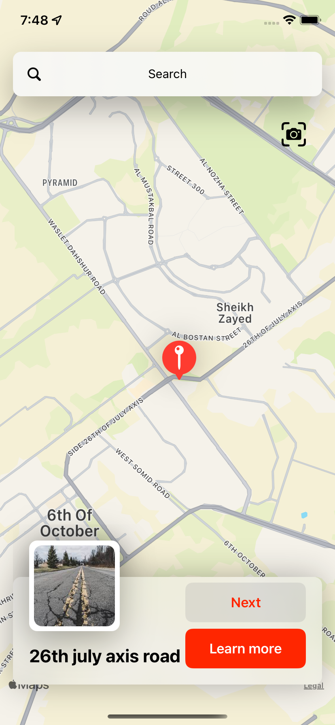

This is the Frist page which the user gets into the Road Assistance app, This pin refers to the first defect in the Database.

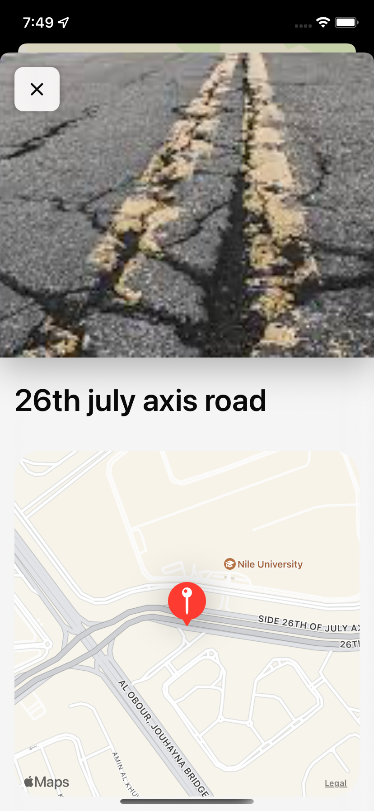

This page shows the details of the defect which are its specific location on map and the detailed picture.

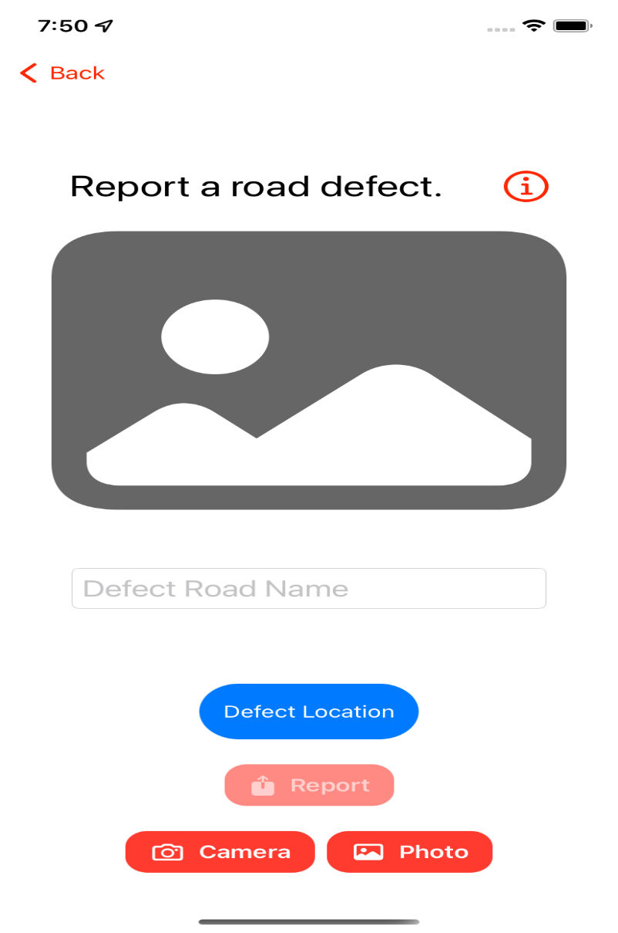

This page is for the user report, this report allows the user to capture a photo of the defect, road name of the defect and the coordinates of the defect then send this report to the Database.

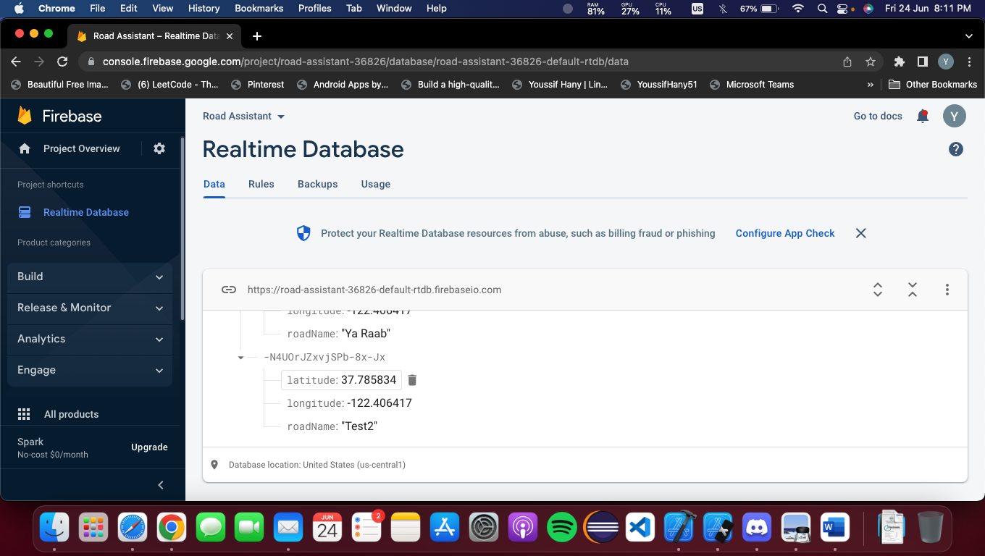

This Realtime database is where all the defects are saved and being fetched, this part is used for saving Road name and Coordinates.

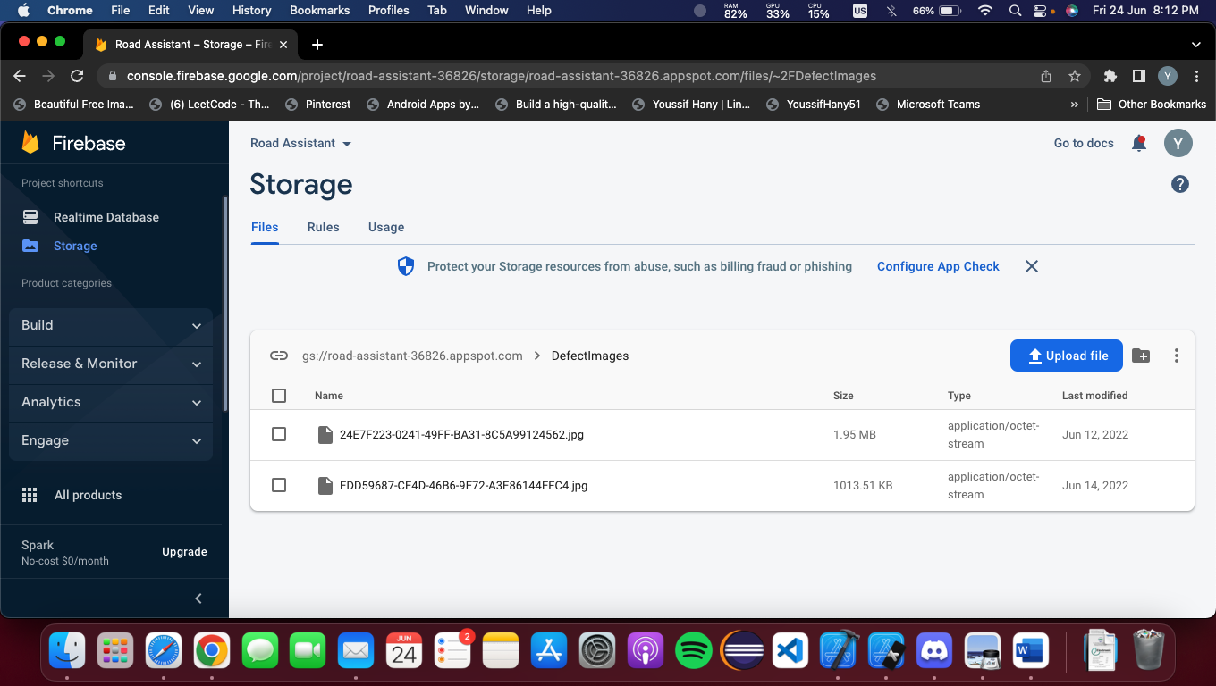

This firebase storge is used for uploading the defect image ONLY.

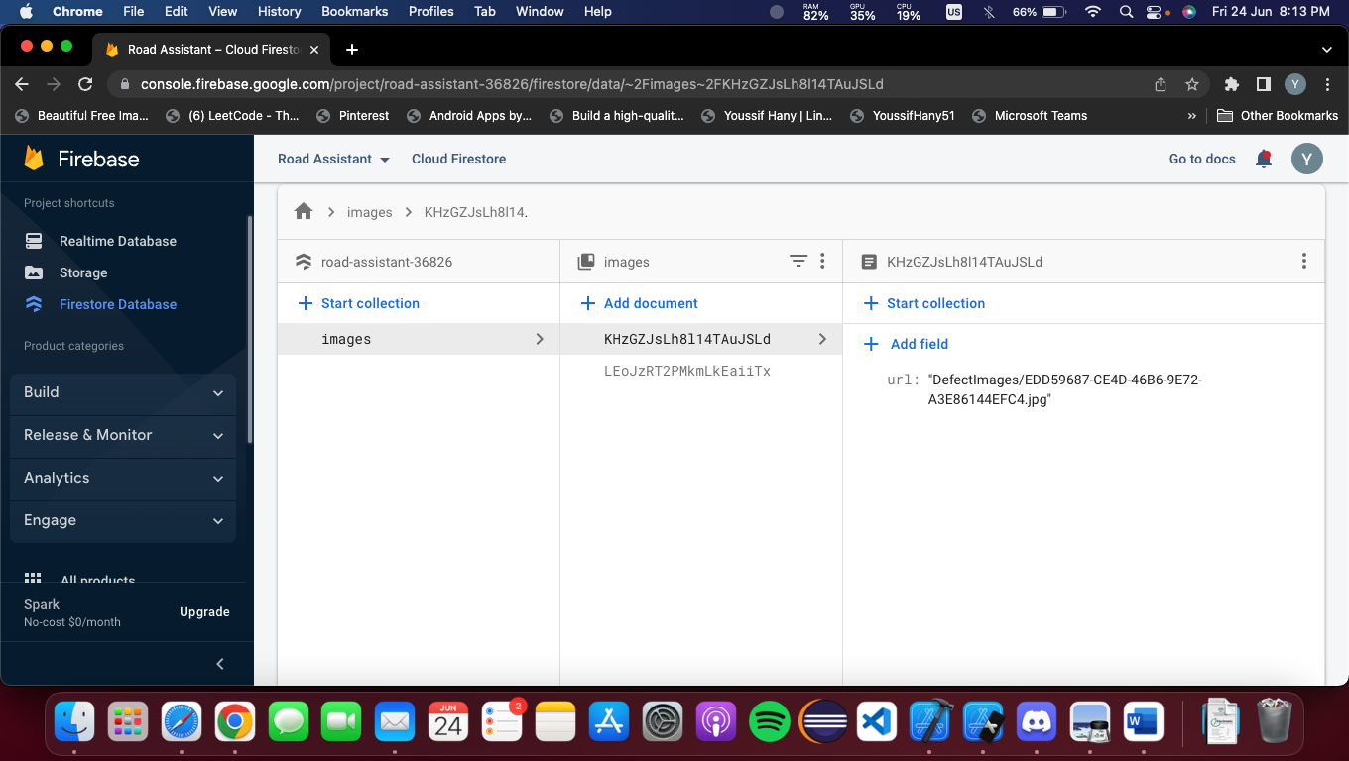

This firestore Database is used for saving the defect image link which is the link of the image saved in firebase storge then it being fetched through the app by downloading the image via this link.

**Xcode**

Xcode is Apple's integrated development environment (IDE) for [macOS](https://en.wikipedia.org/wiki/MacOS" \o "MacOS), used to [develop software](https://en.wikipedia.org/wiki/Software_development" \o "Software development) for macOS, [iOS](https://en.wikipedia.org/wiki/IOS" \o "IOS), [iPadOS](https://en.wikipedia.org/wiki/IPadOS" \o "IPadOS), [watchOS](https://en.wikipedia.org/wiki/WatchOS" \o "WatchOS), and [tvOS](https://en.wikipedia.org/wiki/TvOS" \o "TvOS). It was initially released in late 2003; the latest stable release is version 13.4.1, released on June 2, 2022, and is available via the [Mac App Store](https://en.wikipedia.org/wiki/Mac_App_Store" \o "Mac App Store) free of charge for [macOS Monterey](https://en.wikipedia.org/wiki/MacOS_Monterey" \o "MacOS Monterey) users.[[4]](https://en.wikipedia.org/wiki/Xcode" \l "cite_note-Xcode_on_the_Mac_App_Store-4) [Registered developers](https://en.wikipedia.org/wiki/Mac_Developer_Program" \o "Mac Developer Program) can download [preview releases](https://en.wikipedia.org/wiki/Software_release_life_cycle" \o "Software release life cycle) and prior versions of the suite through the [Apple Developer](https://en.wikipedia.org/wiki/Apple_Developer" \o "Apple Developer) website.[[5]](https://en.wikipedia.org/wiki/Xcode" \l "cite_note-5) Xcode includes Command Line Tools (CLT), which enable [UNIX](https://en.wikipedia.org/wiki/UNIX" \o "UNIX)-style development via the [Terminal app](https://en.wikipedia.org/wiki/Terminal_(macOS)" \o "Terminal (macOS)) in macOS.[[6]](https://en.wikipedia.org/wiki/Xcode" \l "cite_note-6) They can also be downloaded and installed without the [GUI](https://en.wikipedia.org/wiki/GUI" \o "GUI).

Xcode 14 includes everything you need to develop, test, and distribute apps across all Apple platforms. Leverage the simplicity and power of Swift and SwiftUI with a new multiplatform app experience, code faster with enhanced editor features, and start testing and deploying from Xcode Cloud to TestFlight and the App Store. Creating amazing apps has never been easier.

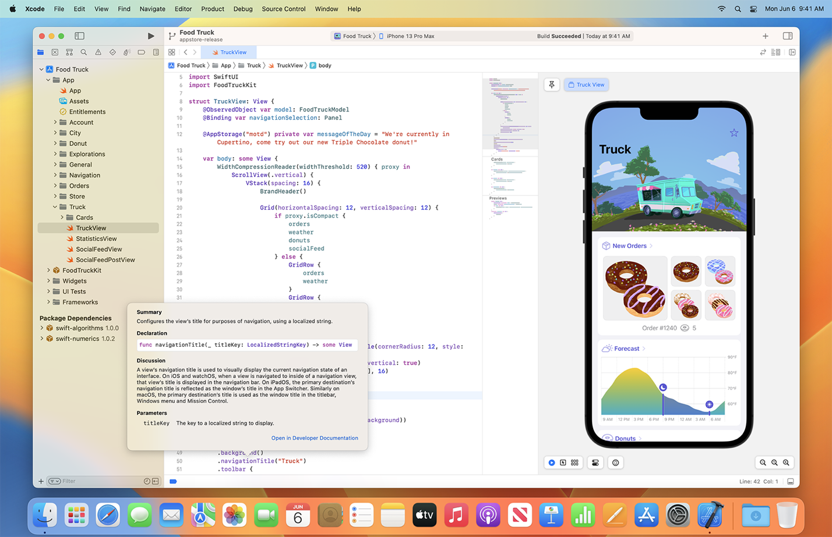

**Lighter. Faster.**

Xcode 14 lets you get started faster than ever with a binary that’s 30% smaller than before. Now with downloadable simulator runtimes for watchOS and tvOS, Xcode makes the latest platforms available as you need them.

Projects build up to 25% faster thanks to improved parallelism in all build and link phases.

And the new Build Timeline helps identify unexpectedly long-running build tasks and bottlenecks in your build.

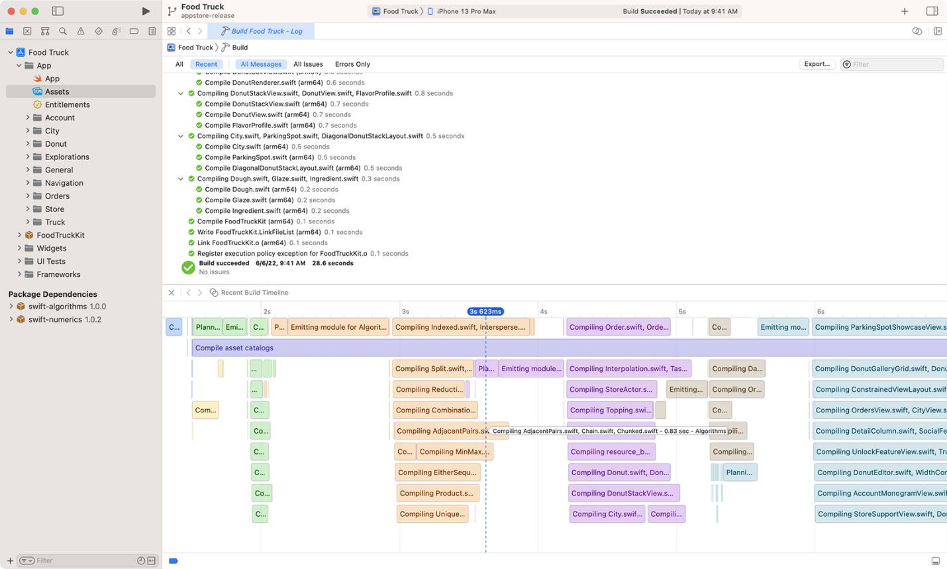

**Designed for multiplatform**

The new multiplatform target creates a single SwiftUI interface for use across iOS, iPadOS, macOS, and tvOS. Your code is easier to maintain, and ready to be customized to take advantage of each platform’s unique capabilities.

With the redesigned App Icon experience in Asset Catalogs, you can provide a single icon size for all platforms and Xcode will generate all the rest.

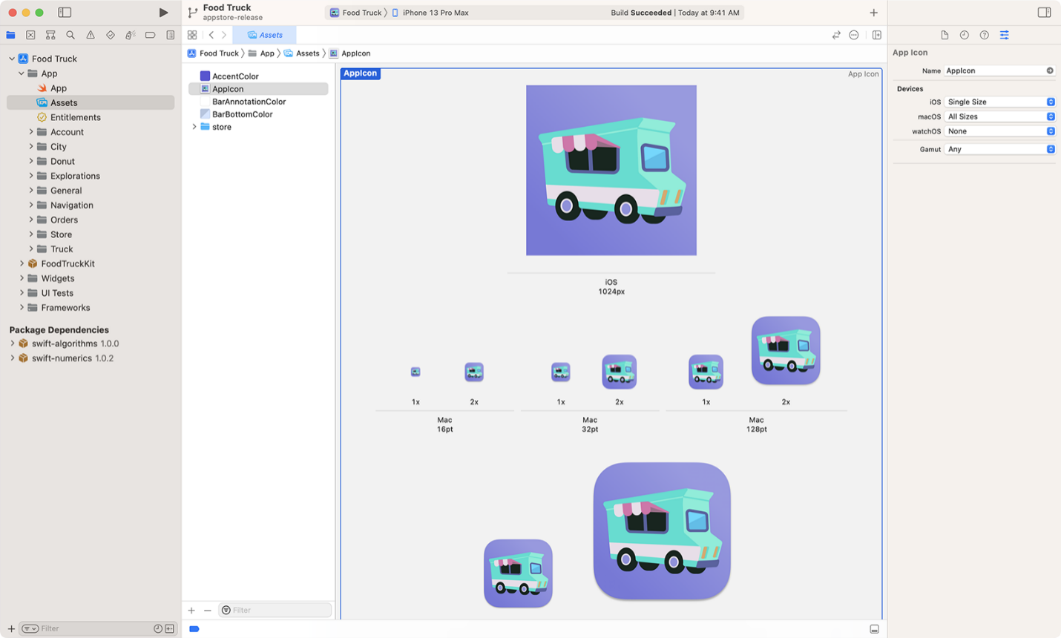

**Productive coding**

Be more productive than ever with many language and editing improvements. Smarter code completion and additional dynamic snippets will get you the code you want more quickly. While you scroll, code structure (like function declarations) stays visible so you always know where you are. And regular expressions in Swift are integrated with syntax highlighting, refactoring operations, and more.

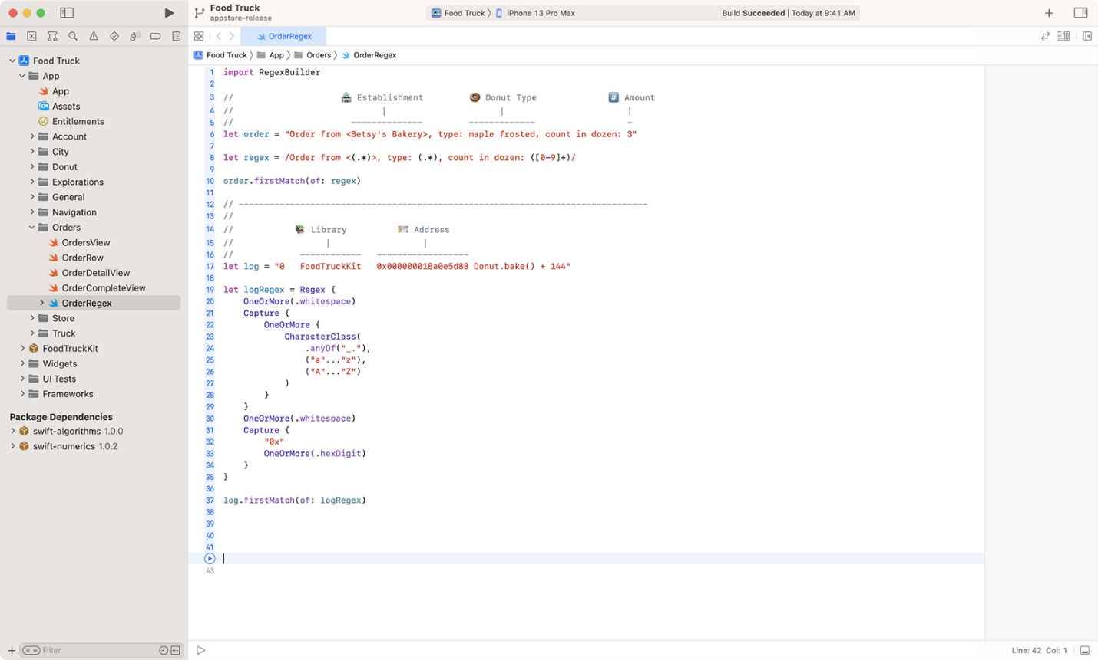

**Swift, SwiftUI, Swift Package**

Swift, SwiftUI, and Xcode 14 work together as one. SwiftUI previews are immediately interactive, and UI variations, such as light and dark appearances, are just a click away. The new template for Instruments makes it easy to debug and optimize usage of distributed actors and other Swift concurrency features. And with build and command package plug-ins, you can customize Xcode and your build process like never before.

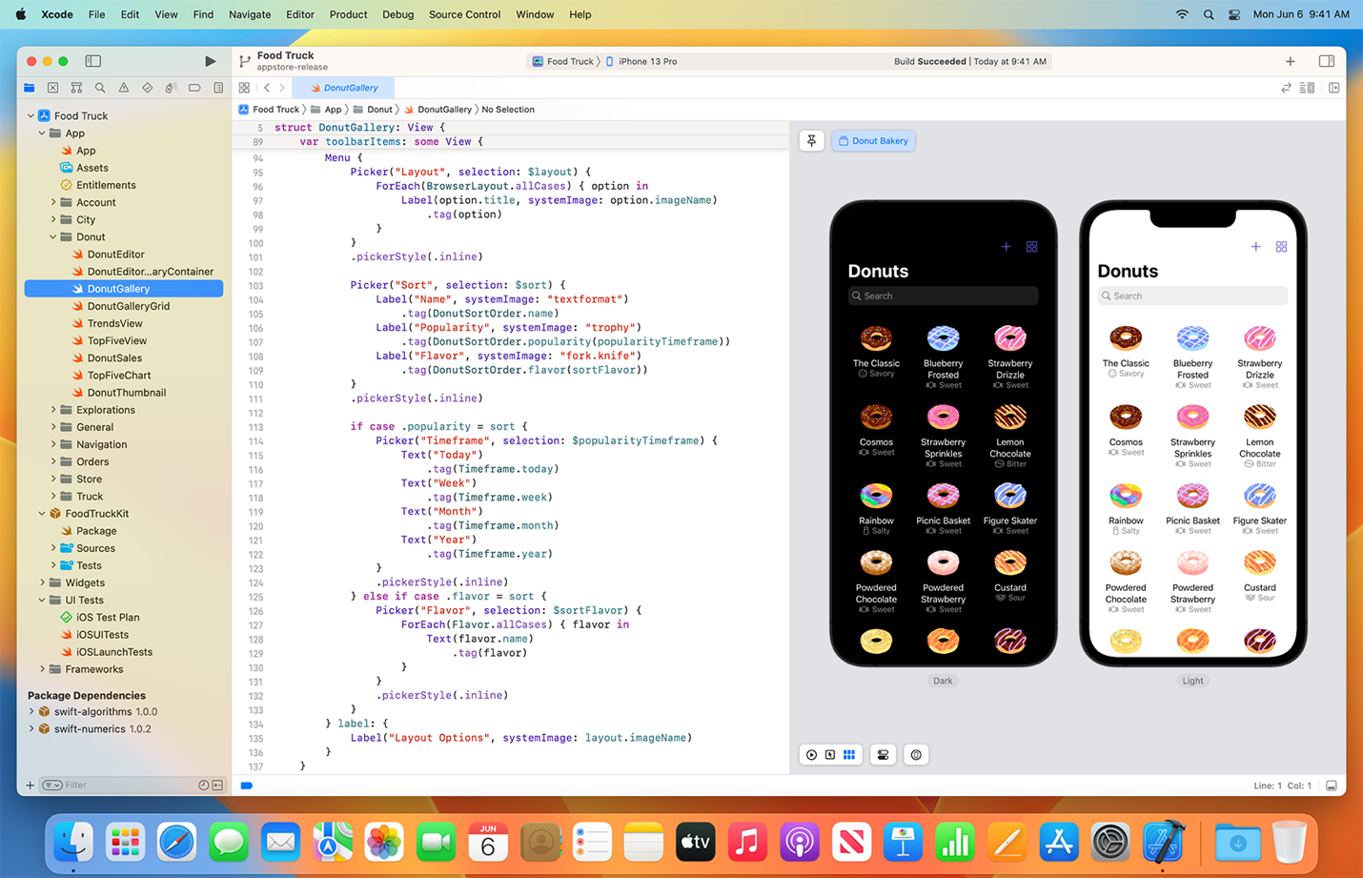

**Major features**

Xcode supports [source code](https://en.wikipedia.org/wiki/Source_code" \o "Source code) for the [programming languages](https://en.wikipedia.org/wiki/Programming_language" \o "Programming language): [C](https://en.wikipedia.org/wiki/C_(programming_language)" \o "C (programming language)), [C++](https://en.wikipedia.org/wiki/C%2B%2B" \o "C++), [Objective-C](https://en.wikipedia.org/wiki/Objective-C" \o "Objective-C), [Objective-C++](https://en.wikipedia.org/wiki/Objective-C%2B%2B" \o "Objective-C++), [Java](https://en.wikipedia.org/wiki/Java_(programming_language)" \o "Java (programming language)), [AppleScript](https://en.wikipedia.org/wiki/AppleScript" \o "AppleScript), [Python](https://en.wikipedia.org/wiki/Python_(programming_language)" \o "Python (programming language)), [Ruby](https://en.wikipedia.org/wiki/Ruby_(programming_language)" \o "Ruby (programming language)), [ResEdit](https://en.wikipedia.org/wiki/ResEdit" \o "ResEdit) (Rez), and [Swift](https://en.wikipedia.org/wiki/Swift_(programming_language)" \o "Swift (programming language)), with a variety of programming models, including but not limited to [Cocoa](https://en.wikipedia.org/wiki/Cocoa_(API)" \o "Cocoa (API)), [Carbon](https://en.wikipedia.org/wiki/Carbon_(API)" \o "Carbon (API)), and Java. Third parties have added support for [GNU Pascal](https://en.wikipedia.org/wiki/GNU_Pascal" \o "GNU Pascal), [Free Pascal](https://en.wikipedia.org/wiki/Free_Pascal" \o "Free Pascal), [Ada](https://en.wikipedia.org/wiki/Ada_(programming_language)" \o "Ada (programming language)), [C#](https://en.wikipedia.org/wiki/C_Sharp_(programming_language)" \o "C Sharp (programming language)), [Go](https://en.wikipedia.org/wiki/Go_(programming_language)" \o "Go (programming language)), [Perl](https://en.wikipedia.org/wiki/Perl" \o "Perl), and [D](https://en.wikipedia.org/wiki/D_(programming_language)" \o "D (programming language)).

Xcode can build *[fat binary](https://en.wikipedia.org/wiki/Fat_binary" \o "Fat binary)* ([universal binary](https://en.wikipedia.org/wiki/Universal_binary" \o "Universal binary)) files containing code for multiple architectures with the [Mach-O](https://en.wikipedia.org/wiki/Mach-O" \o "Mach-O) executable format. These helped ease the transitions from [32-bit](https://en.wikipedia.org/wiki/32-bit" \o "32-bit) [PowerPC](https://en.wikipedia.org/wiki/PowerPC" \o "PowerPC)to [64-bit](https://en.wikipedia.org/wiki/64-bit" \o "64-bit) PowerPC, from PowerPC to [Intel](https://en.wikipedia.org/wiki/Intel" \o "Intel) [x86](https://en.wikipedia.org/wiki/X86" \o "X86), from 32-bit to 64-bit Intel, and from x86 to [Apple silicon](https://en.wikipedia.org/wiki/Apple_silicon" \o "Apple silicon) by allowing developers to distribute a single application to users and letting the operating system automatically choose the appropriate architecture at runtime. Using the [iOS SDK](https://en.wikipedia.org/wiki/IOS_SDK" \o "IOS SDK), tvOS SDK, and watchOS SDK, Xcode can also be used to compile and debug applications for [iOS](https://en.wikipedia.org/wiki/IOS" \o "IOS), [iPadOS](https://en.wikipedia.org/wiki/IPadOS" \o "IPadOS), [tvOS](https://en.wikipedia.org/wiki/TvOS" \o "TvOS), and [watchOS](https://en.wikipedia.org/wiki/WatchOS" \o "WatchOS).

Xcode includes the GUI tool [Instruments](https://en.wikipedia.org/wiki/Instruments_(application)" \o "Instruments (application)), which runs atop a dynamic tracing framework, [DTrace](https://en.wikipedia.org/wiki/DTrace" \o "DTrace), created by [Sun Microsystems](https://en.wikipedia.org/wiki/Sun_Microsystems" \o "Sun Microsystems) and released as part of [OpenSolaris](https://en.wikipedia.org/wiki/OpenSolaris" \o "OpenSolaris).

Xcode also integrates built-in support for [source code management](https://en.wikipedia.org/wiki/Version_control" \o "Version control) using the [Git](https://en.wikipedia.org/wiki/Git" \o "Git) [version control](https://en.wikipedia.org/wiki/Version_control" \o "Version control) system and protocol, allowing the user to create and [clone](https://en.wikipedia.org/wiki/Version_control" \l "Common_terminology" \o "Version control) Git [repositories](https://en.wikipedia.org/wiki/Repository_(version_control)" \o "Repository (version control)) (which can be hosted on source code repository hosting sites such as [GitHub](https://en.wikipedia.org/wiki/GitHub" \o "GitHub), [Bitbucket](https://en.wikipedia.org/wiki/Bitbucket" \o "Bitbucket), and [Perforce](https://en.wikipedia.org/wiki/Perforce" \o "Perforce), or self-hosted using open-source software such as [GitLab](https://en.wikipedia.org/wiki/GitLab" \o "GitLab)), and to [commit](https://en.wikipedia.org/wiki/Commit_(version_control)" \o "Commit (version control)), [push](https://en.wikipedia.org/wiki/Version_control" \l "Common_terminology" \o "Version control), and [pull](https://en.wikipedia.org/wiki/Version_control" \l "Common_terminology" \o "Version control)changes, all from within Xcode, automating tasks that would traditionally be performed by using Git from the [command line](https://en.wikipedia.org/wiki/Command-line_interface" \o "Command-line interface).

**Swift (programming language)**

Swift is a [general-purpose](https://en.wikipedia.org/wiki/General-purpose_programming_language" \o "General-purpose programming language), [multi-paradigm](https://en.wikipedia.org/wiki/Multi-paradigm_programming_language" \o "Multi-paradigm programming language), [compiled](https://en.wikipedia.org/wiki/Compiled_language" \o "Compiled language) [programming language](https://en.wikipedia.org/wiki/Programming_language" \o "Programming language) developed by [Apple Inc.](https://en.wikipedia.org/wiki/Apple_Inc." \o "Apple Inc.) and [the open-source community](https://en.wikipedia.org/wiki/Open-source-software_movement" \o "Open-source-software movement). First released in 2014, Swift was developed as a replacement for Apple's earlier programming language [Objective-C](https://en.wikipedia.org/wiki/Objective-C" \o "Objective-C), as Objective-C had been largely unchanged since the early 1980s and lacked modern language features. Swift works with Apple's [Cocoa](https://en.wikipedia.org/wiki/Cocoa_(API)" \o "Cocoa (API)) and [Cocoa Touch](https://en.wikipedia.org/wiki/Cocoa_Touch" \o "Cocoa Touch)[frameworks](https://en.wikipedia.org/wiki/Software_framework" \o "Software framework), and a key aspect of Swift's design was the ability to interoperate with the huge body of existing Objective-C code developed for Apple products over the previous decades. It was built with the open source [LLVM](https://en.wikipedia.org/wiki/LLVM" \o "LLVM) [compiler](https://en.wikipedia.org/wiki/Compiler" \o "Compiler) framework and has been included in [Xcode](https://en.wikipedia.org/wiki/Xcode" \o "Xcode) since version 6, released in 2014. On Apple platforms, it uses the Objective-C [runtime library](https://en.wikipedia.org/wiki/Runtime_library" \o "Runtime library), which allows [C](https://en.wikipedia.org/wiki/C_(programming_language)" \o "C (programming language)), [Objective-C](https://en.wikipedia.org/wiki/Objective-C" \o "Objective-C), [C++](https://en.wikipedia.org/wiki/C%2B%2B" \o "C++)and Swift code to run within one program.

Apple intended Swift to support many core concepts associated with [Objective-C](https://en.wikipedia.org/wiki/Objective-C" \o "Objective-C), notably [dynamic dispatch](https://en.wikipedia.org/wiki/Dynamic_dispatch" \o "Dynamic dispatch), widespread [late binding](https://en.wikipedia.org/wiki/Late_binding" \o "Late binding), [extensible programming](https://en.wikipedia.org/wiki/Extensible_programming" \o "Extensible programming) and similar features, but in a "safer" way, making it easier to catch [software bugs](https://en.wikipedia.org/wiki/Software_bugs" \o "Software bugs); Swift has features addressing some common [programming errors](https://en.wikipedia.org/wiki/Programming_error" \o "Programming error) like [null pointer](https://en.wikipedia.org/wiki/Null_pointer" \o "Null pointer) [dereferencing](https://en.wikipedia.org/wiki/Dereference_operator" \o "Dereference operator) and provides [syntactic sugar](https://en.wikipedia.org/wiki/Syntactic_sugar" \o "Syntactic sugar) to help avoid the [pyramid of doom](https://en.wikipedia.org/wiki/Pyramid_of_doom_(programming)" \o "Pyramid of doom (programming)). Swift supports the concept of [protocol](https://en.wikipedia.org/wiki/Protocol_(object-oriented_programming)" \o "Protocol (object-oriented programming)) extensibility, an extensibility system that can be applied to types, [structs](https://en.wikipedia.org/wiki/Record_(computer_science)" \o "Record (computer science)) and [classes](https://en.wikipedia.org/wiki/Class_(computer_programming)" \o "Class (computer programming)), which Apple promotes as a real change in programming paradigms they term "protocol-oriented programming" (similar to [traits](https://en.wikipedia.org/wiki/Trait_(computer_programming)" \o "Trait (computer programming))).

Swift was introduced at Apple's [2014 Worldwide Developers Conference](https://en.wikipedia.org/wiki/Apple_Worldwide_Developers_Conference" \l "2010s" \o "Apple Worldwide Developers Conference) (WWDC). It underwent an upgrade to version 1.2 during 2014 and a major upgrade to Swift 2 at WWDC 2015. Initially a [proprietary language](https://en.wikipedia.org/wiki/Proprietary_programming_language" \o "Proprietary programming language), version 2.2 was made [open-source software](https://en.wikipedia.org/wiki/Open-source_software" \o "Open-source software) under the [Apache License](https://en.wikipedia.org/wiki/Apache_License" \o "Apache License) 2.0 on December 3, 2015, for Apple's platforms and [Linux](https://en.wikipedia.org/wiki/Linux" \o "Linux).

Through version 3.0 the syntax of Swift went through significant evolution, with the core team making source stability a focus in later versions. In the first quarter of 2018 Swift surpassed [Objective-C](https://en.wikipedia.org/wiki/Objective-C" \o "Objective-C) in measured popularity.

Swift 4.0, released in 2017, introduced several changes to some built-in classes and structures. Code written with previous versions of Swift can be updated using the migration functionality built into Xcode. Swift 5, released in March 2019, introduced a stable binary interface on Apple platforms, allowing the Swift runtime to be incorporated into Apple operating systems. It is source compatible with Swift 4.

Swift 5.1 was officially released in September 2019. Swift 5.1 builds on the previous version of Swift 5 by extending the stable features of the language to compile-time with the introduction of module stability. The introduction of module stability makes it possible to create and share binary frameworks that will work with future releases of Swift.

Swift 5.5, officially announced by Apple at the 2021 [WWDC](https://en.wikipedia.org/wiki/Apple_Worldwide_Developers_Conference" \o "Apple Worldwide Developers Conference), significantly expands language support for [concurrency](https://en.wikipedia.org/wiki/Concurrency_(computer_science)" \o "Concurrency (computer science)) and [asynchronous code](https://en.wikipedia.org/wiki/Asynchrony_(computer_programming)" \o "Asynchrony (computer programming)), notably introducing a unique version of the [actor model](https://en.wikipedia.org/wiki/Actor_model" \o "Actor model).

**Libraries, runtime and development**

On Apple systems, Swift uses the same runtime as the extant [Objective-C](https://en.wikipedia.org/wiki/Objective-C" \o "Objective-C) system, but requires iOS 7 or macOS 10.9 or higher. It also depends on [Grand Central Dispatch](https://en.wikipedia.org/wiki/Grand_Central_Dispatch" \o "Grand Central Dispatch). Swift and Objective-C code can be used in one program, and by extension, C and C++ also. In contrast to C, [C++](https://en.wikipedia.org/wiki/C%2B%2B" \o "C++) code cannot be used directly from Swift. An Objective-C or C wrapper must be created between Swift and C++. In the case of Objective-C, Swift has considerable access to the object model, and can be used to subclass, extend and use Objective-C code to provide protocol support. The converse is not true: a Swift class cannot be subclassed in Objective-C.

To aid development of such programs, and the re-use of extant code, Xcode 6 and higher offers a semi-automated system that builds and maintains a *bridging header* to expose Objective-C code to Swift. This takes the form of an additional [header file](https://en.wikipedia.org/wiki/Header_file" \o "Header file) that simply defines or imports all of the Objective-C symbols that are needed by the project's Swift code. At that point, Swift can refer to the types, functions, and variables declared in those imports as though they were written in Swift. Objective-C code can also use Swift code directly, by importing an automatically maintained header file with Objective-C declarations of the project's Swift symbols. For instance, an Objective-C file in a mixed project called "MyApp" could access Swift classes or functions with the code #import "MyApp-Swift.h". Not all symbols are available through this mechanism, however—use of Swift-specific features like generic types, non-object optional types, sophisticated enums, or even Unicode identifiers may render a symbol inaccessible from Objective-C.

Swift also has limited support for *attributes*, metadata that is read by the development environment, and is not necessarily part of the compiled code. Like Objective-C, attributes use the @ syntax, but the currently available set is small. One example is the @IBOutlet attribute, which marks a given value in the code as an *outlet*, available for use within [Interface Builder](https://en.wikipedia.org/wiki/Interface_Builder" \o "Interface Builder) (IB). An *outlet* is a device that binds the value of the on-screen display to an object in code.

On non-Apple systems, Swift does not depend on an Objective-C runtime or other Apple system libraries; a set of Swift "Corelib" implementations replace them. These include a "swift-corelibs-foundation" to stand in for the [Foundation Kit](https://en.wikipedia.org/wiki/Foundation_Kit" \o "Foundation Kit), a "swift-corelibs-libdispatch" to stand in for the Grand Central Dispatch, and an "swift-corelibs-xctest" to stand in for the XCTest APIs from [Xcode](https://en.wikipedia.org/wiki/Xcode" \o "Xcode).

As of 2019, with Xcode 11, Apple has also added a major new UI paradigm called SwiftUI. SwiftUI replaces the older [Interface Builder](https://en.wikipedia.org/wiki/Interface_Builder" \o "Interface Builder) paradigm with a new declarative development paradigm.

Memory management

Swift uses [Automatic Reference Counting](https://en.wikipedia.org/wiki/Automatic_Reference_Counting" \o "Automatic Reference Counting) (ARC) to [manage memory](https://en.wikipedia.org/wiki/Memory_management" \o "Memory management). Apple used to require manual memory management in Objective-C, but introduced ARC in 2011 to allow for easier memory allocation and deallocation.[[78]](https://en.wikipedia.org/wiki/Swift_(programming_language)" \l "cite_note-78) One problem with ARC is the possibility of creating a *[strong reference cycle](https://en.wikipedia.org/wiki/Reference_counting" \l "reference_cycle" \o "Reference counting)*, where objects reference each other in a way that you can reach the object you started from by following references (e.g. A references B, B references A). This causes them to become leaked into memory as they are never released. Swift provides the keywords weak and unowned to prevent strong reference cycles. Typically a parent-child relationship would use a strong reference while a child-parent would use either weak reference, where parents and children can be unrelated, or unowned where a child always has a parent, but parent may not have a child. Weak references must be optional variables, since they can change and become nil.

A closure within a class can also create a strong reference cycle by capturing self references. Self references to be treated as weak or unowned can be indicated using a *capture list.*

Debugging and other elements

A key element of the Swift system is its ability to be cleanly debugged and run within the development environment, using a [read–eval–print loop](https://en.wikipedia.org/wiki/Read%E2%80%93eval%E2%80%93print_loop" \o "Read–eval–print loop) (REPL), giving it interactive properties more in common with the scripting abilities of Python than traditional [system programming](https://en.wikipedia.org/wiki/System_programming" \o "System programming) languages. The REPL is further enhanced with [playgrounds](https://en.wikipedia.org/wiki/Swift_Playgrounds" \o "Swift Playgrounds), interactive views running within the Xcode environment that respond to code or debugger changes on-the-fly. Playgrounds allow programmers to add in Swift code along with markdown documentation. If some code changes over time or with regard to some other ranged input value, the view can be used with the Timeline Assistant to demonstrate the output in an animated way. In addition, Xcode has debugging features for Swift development including breakpoints, step through and step over statements, as well as UI element placement breakdowns for app developers.

Apple says that Swift is "an industrial-quality programming language that's as expressive and enjoyable as a scripting language".

Comparisons to other languages

Swift is considered a [C family programming language](https://en.wikipedia.org/wiki/List_of_C-family_programming_languages" \o "List of C-family programming languages) and is similar to C in various ways:

* Most C operators are used in Swift, but there are some new operators, for example to support integer operations with overflow (see under differences).
* [Curly braces](https://en.wikipedia.org/wiki/Curly_braces" \o "Curly braces) are used to group statements.
* Variables are assigned using an [equals sign](https://en.wikipedia.org/wiki/Equals_sign" \o "Equals sign), but compared using [two consecutive equals signs](https://en.wikipedia.org/wiki/%3D%3D" \o "==). A new identity operator, ===, is provided to check if two data elements refer to the same [object](https://en.wikipedia.org/wiki/Pointer_(computing)" \o "Pointer (computing)).
* Control statements while, if, and switch are similar, but have extended functions, e.g., a switch that takes non-integer cases, while and if supporting [pattern matching](https://en.wikipedia.org/wiki/Pattern_matching" \o "Pattern matching) and conditionally unwrapping optionals, for uses the **for** i **in** 1...10 syntax.
* [Square brackets](https://en.wikipedia.org/wiki/Square_brackets" \o "Square brackets) are used with [arrays](https://en.wikipedia.org/wiki/Array_data_structure" \o "Array data structure), both to declare them and to get a value at a given index in one of them.

It also has similarities to Objective-C:

* Basic numeric types (Int, UInt, Float, Double)
* Class methods are inherited, like instance methods; self in class methods is the class the method was called on.
* Similar for...in enumeration syntax.

Differences from Objective-C include:

* Statements do not need to end with semicolons (;), though these must be used to allow more than one statement on a line.
* No header files.
* Uses [type inference](https://en.wikipedia.org/wiki/Type_inference" \o "Type inference).
* [Generic programming](https://en.wikipedia.org/wiki/Generic_programming" \o "Generic programming).
* Functions are [first-class](https://en.wikipedia.org/wiki/First_class_function" \o "First class function) objects.
* Enumeration cases can have associated data ([algebraic data types](https://en.wikipedia.org/wiki/Algebraic_data_type" \o "Algebraic data type)).
* Operators can be redefined for classes ([operator overloading](https://en.wikipedia.org/wiki/Operator_overloading" \o "Operator overloading)), and new operators can be defined.
* Strings fully support [Unicode](https://en.wikipedia.org/wiki/Unicode" \o "Unicode). Most Unicode characters can be used in either identifiers or operators.
* No [exception handling](https://en.wikipedia.org/wiki/Exception_handling" \o "Exception handling). Swift 2 introduces a different and incompatible error-handling model.
* Several features of earlier [C-family languages](https://en.wikipedia.org/wiki/List_of_C-family_programming_languages" \o "List of C-family programming languages) that are easy to misuse have been removed:
  + [Pointers](https://en.wikipedia.org/wiki/Pointer_(computer_programming)" \o "Pointer (computer programming)) are not exposed by default. There is no need for the programmer to keep track of and mark names for referencing or dereferencing.
  + Assignments return no value. This prevents the common error of writing i = 0 instead of i == 0 by throwing a compile-time error.
  + No need to use break statements in [switch](https://en.wikipedia.org/wiki/Switch_statement" \o "Switch statement) blocks. Individual cases do not fall through to the next case unless the fallthrough statement is used.
  + Variables and constants are always initialized and array bounds are always checked.
  + [Integer overflows](https://en.wikipedia.org/wiki/Integer_overflow" \o "Integer overflow), which result in [undefined behavior](https://en.wikipedia.org/wiki/Undefined_behavior" \o "Undefined behavior) for signed integers in C, are trapped as a run-time error in Swift. Programmers can choose to allow overflows by using the special arithmetical operators &+, &-, &\*, &/ and &%. The properties min and max are defined in Swift for all integer types and can be used to safely check for potential overflows, versus relying on constants defined for each type in external libraries.
  + The one-statement form of if and while, which allows for the omission of braces around the statement, is unsupported.
  + C-style enumeration for (int i = 0; i < c; i++), which is prone to [off-by-one errors](https://en.wikipedia.org/wiki/Off-by-one_error" \o "Off-by-one error), is unsupported (from Swift 3 onward).
  + The pre- and post- [increment and decrement operators](https://en.wikipedia.org/wiki/Increment_and_decrement_operators" \o "Increment and decrement operators) (i++, --i ...) are unsupported (from Swift 3 onward), more so since C-style for statements are also unsupported from Swift 3 onward.

Development and other implementations

Since the language is open-source, there are prospects of it being ported to the web. Some web frameworks have already been developed, such as [IBM](https://en.wikipedia.org/wiki/IBM" \o "IBM)'s [Kitura](https://en.wikipedia.org/wiki/Kitura" \o "Kitura), [Perfect](https://en.wikipedia.org/wiki/Perfect_(server_framework)" \o "Perfect (server framework)) and [Vapor](https://en.wikipedia.org/wiki/Vapor_(Server-side_Swift)" \o "Vapor (Server-side Swift)).

An official "Server APIs" work group has also been started by Apple, with members of the Swift developer community playing a central role.

A second free implementation of Swift that targets [Cocoa](https://en.wikipedia.org/wiki/Cocoa_(API)" \o "Cocoa (API)), [Microsoft](https://en.wikipedia.org/wiki/Microsoft" \o "Microsoft)'s [Common Language Infrastructure](https://en.wikipedia.org/wiki/Common_Language_Infrastructure" \o "Common Language Infrastructure) ([.NET](https://en.wikipedia.org/wiki/.NET_Framework" \o ".NET Framework)), and the [Java](https://en.wikipedia.org/wiki/Java_(software_platform)" \o "Java (software platform)) and [Android](https://en.wikipedia.org/wiki/Android_(operating_system)" \o "Android (operating system)) platform exists as part of the *Elements Compiler* from [RemObjects Software](https://en.wikipedia.org/wiki/RemObjects_Software" \o "RemObjects Software).

By combining [toolchains](https://en.wikipedia.org/wiki/Toolchain" \o "Toolchain) from LLVM and [Macintosh Programmer's Workshop](https://en.wikipedia.org/wiki/Macintosh_Programmer%27s_Workshop" \o "Macintosh Programmer's Workshop), it is possible to run a very small subset of the language on [Mac OS 9](https://en.wikipedia.org/wiki/Mac_OS_9" \o "Mac OS 9).

**Firebase Realtime Database** - Store and sync data with our NoSQL cloud database. Data is synced across all clients in realtime, and remains available when your app goes offline.

The Firebase Realtime Database is a cloud-hosted database. Data is stored as JSON and synchronized in realtime to every connected client. When you build cross-platform apps with our Apple platforms, Android, and JavaScript SDKs, all of your clients share one Realtime Database instance and automatically receive updates with the newest data.

**Key capabilities**

|  |  |
| --- | --- |
| Realtime | Instead of typical HTTP requests, the Firebase Realtime Database uses data synchronization—every time data changes, any connected device receives that update within milliseconds. Provide collaborative and immersive experiences without thinking about networking code. |
| Offline | Firebase apps remain responsive even when offline because the Firebase Realtime Database SDK persists your data to disk. Once connectivity is reestablished, the client device receives any changes it missed, synchronizing it with the current server state. |
| Accessible from Client Devices | The Firebase Realtime Database can be accessed directly from a mobile device or web browser; there’s no need for an application server. Security and data validation are available through the Firebase Realtime Database Security Rules, expression-based rules that are executed when data is read or written. |
| Scale across multiple databases | With Firebase Realtime Database on the Blaze pricing plan, you can support your app's data needs at scale by splitting your data across multiple database instances in the same Firebase project. Streamline authentication with Firebase Authentication on your project and authenticate users across your database instances. Control access to the data in each database with custom Firebase Realtime Database Rules for each database instance. |

**How does it work?**

The Firebase Realtime Database lets you build rich, collaborative applications by allowing secure access to the database directly from client-side code. Data is persisted locally, and even while offline, realtime events continue to fire, giving the end user a responsive experience. When the device regains connection, the Realtime Database synchronizes the local data changes with the remote updates that occurred while the client was offline, merging any conflicts automatically.

The Realtime Database provides a flexible, expression-based rules language, called Firebase Realtime Database Security Rules, to define how your data should be structured and when data can be read from or written to. When integrated with Firebase Authentication, developers can define who has access to what data, and how they can access it.

The Realtime Database is a NoSQL database and as such has different optimizations and functionality compared to a relational database. The Realtime Database API is designed to only allow operations that can be executed quickly. This enables you to build a great realtime experience that can serve millions of users without compromising on responsiveness. Because of this, it is important to think about how users need to access your data and then [structure it accordingly](https://firebase.google.com/docs/database/web/structure-data).

**Implementation path**

|  |  |
| --- | --- |
| Integrate the Firebase Realtime Database SDKs | Quickly include clients via Gradle, CocoaPods, or a script include. |
| Create Realtime Database References | Reference your JSON data, such as "users/user:1234/phone\_number" to set data or subscribe to data changes. |
| Set Data and Listen for Changes | Use these references to write data or subscribe to changes. |
| Enable Offline Persistence | Allow data to be written to the device's local disk so it can be available while offline. |
| Secure your data | Use Firebase Realtime Database Security Rules to secure your data. |

**Looking to store other types of data?**

* [Cloud Firestore](https://firebase.google.com/docs/firestore) is a flexible, scalable database for mobile, web, and server development from Firebase and Google Cloud Platform. To learn more about the differences between database options, see [Choose a database: Cloud Firestore or Realtime Database](https://firebase.google.com/docs/firestore/rtdb-vs-firestore).
* [Firebase Remote Config](https://firebase.google.com/docs/remote-config) stores developer specified key-value pairs to change the behavior and appearance of your app without requiring users to download an update.
* [Firebase Hosting](https://firebase.google.com/docs/hosting) hosts the HTML, CSS, and JavaScript for your website as well as other developer-provided assets like graphics, fonts, and icons.
* [Cloud Storage](https://firebase.google.com/docs/storage) stores files such as images, videos, and audio as well as other user-generated content.

Cloud Firestore

Use our flexible, scalable NoSQL cloud database to store and sync data for client- and server-side development.

Cloud Firestore is a flexible, scalable database for mobile, web, and server development from Firebase and Google Cloud. Like Firebase Realtime Database, it keeps your data in sync across client apps through realtime listeners and offers offline support for mobile and web so you can build responsive apps that work regardless of network latency or Internet connectivity. Cloud Firestore also offers seamless integration with other Firebase and Google Cloud products, including Cloud Functions.

**Key capabilities**

|  |  |
| --- | --- |
| Flexibility | The Cloud Firestore data model supports flexible, hierarchical data structures. Store your data in documents, organized into collections. Documents can contain complex nested objects in addition to subcollections. |
| Expressive querying | In Cloud Firestore, you can use queries to retrieve individual, specific documents or to retrieve all the documents in a collection that match your query parameters. Your queries can include multiple, chained filters and combine filtering and sorting. They're also indexed by default, so query performance is proportional to the size of your result set, not your data set. |
| Realtime updates | Like Realtime Database, Cloud Firestore uses data synchronization to update data on any connected device. However, it's also designed to make simple, one-time fetch queries efficiently. |
| Offline support | Cloud Firestore caches data that your app is actively using, so the app can write, read, listen to, and query data even if the device is offline. When the device comes back online, Cloud Firestore synchronizes any local changes back to Cloud Firestore. |
| Designed to scale | Cloud Firestore brings you the best of Google Cloud's powerful infrastructure: automatic multi-region data replication, strong consistency guarantees, atomic batch operations, and real transaction support. We've designed Cloud Firestore to handle the toughest database workloads from the world's biggest apps. |

**How does it work?**

Cloud Firestore is a cloud-hosted, NoSQL database that your Apple, Android, and web apps can access directly via native SDKs. Cloud Firestore is also available in native Node.js, Java, Python, Unity, C++ and Go SDKs, in addition to REST and RPC APIs.

Following Cloud Firestore's NoSQL data model, you store data in documents that contain fields mapping to values. These documents are stored in collections, which are containers for your documents that you can use to organize your data and build queries. Documents support many different [data types](https://firebase.google.com/docs/firestore/manage-data/data-types), from simple strings and numbers, to complex, nested objects. You can also create subcollections within documents and build hierarchical data structures that scale as your database grows. The Cloud Firestore [data model](https://firebase.google.com/docs/firestore/data-model) supports whatever data structure works best for your app. Additionally, querying in Cloud Firestore is expressive, efficient, and flexible. Create shallow queries to retrieve data at the document level without needing to retrieve the entire collection, or any nested subcollections. Add sorting, filtering, and limits to your queries or cursors to paginate your results. To keep data in your apps current, without retrieving your entire database each time an update happens, add realtime listeners. Adding realtime listeners to your app notifies you with a data snapshot whenever the data your client apps are listening to changes, retrieving only the new changes. Protect access to your data in Cloud Firestore with Firebase Authentication and Cloud Firestore Security Rules for Android, Apple platforms, and JavaScript, or Identity and Access Management (IAM) for server-side languages.

**Implementation path**

|  |  |
| --- | --- |
| **Integrate the Cloud Firestore SDKs** | **Quickly include clients via Gradle, CocoaPods, or a script include.** |
| **Secure your data** | Use Cloud Firestore Security Rules or Identity and Access Management (IAM) to secure your data for mobile/web and server development, respectively. |
| **Add Data** | Create documents and collections in your database. |
| **Get Data** | Create queries or use realtime listeners to retrieve data from the database. |

**Cloud Storage for Firebase** - Cloud Storage for Firebase is built for app developers who need to store and serve user-generated content, such as photos or videos. Cloud Storage for Firebase is a powerful, simple, and cost-effective object storage service built for Google scale. The Firebase SDKs for Cloud Storage add Google security to file uploads and downloads for your Firebase apps, regardless of network quality. You can use our SDKs to store images, audio, video, or other user-generated content. On the server, you can use [Google Cloud Storage APIs](https://cloud.google.com/storage/docs/reference/libraries) to access the same files.

**Key capabilities**

|  |  |
| --- | --- |
| Robust operations | Firebase SDKs for Cloud Storage perform uploads and downloads regardless of network quality. Uploads and downloads are robust, meaning they restart where they stopped, saving your users time and bandwidth. |
| Strong security | Firebase SDKs for Cloud Storage integrate with Firebase Authentication to provide simple and intuitive authentication for developers. You can use our declarative security model to allow access based on filename, size, content type, and other metadata. |
| High scalability | Cloud Storage is built for exabyte scale when your app goes viral. Effortlessly grow from prototype to production using the same infrastructure that powers Spotify and Google Photos. |

**How does it work?**

Developers use the Firebase SDKs for Cloud Storage to upload and download files directly from clients. If the network connection is poor, the client is able to retry the operation right where it left off, saving your users time and bandwidth.

Cloud Storage for Firebase stores your files in a [Google Cloud Storage](https://cloud.google.com/storage) bucket, making them accessible through both Firebase and Google Cloud. This allows you the flexibility to upload and download files from mobile clients via the Firebase SDKs for Cloud Storage. In addition, you can do server-side processing such as image filtering or video transcoding using the [Google Cloud Storage APIs](https://cloud.google.com/storage/docs/reference/libraries). Cloud Storage scales automatically, meaning that there's no need to migrate to any other provider. Learn more about all the benefits of our [integration with Google Cloud](https://firebase.google.com/docs/storage/gcp-integration).

The Firebase SDKs for Cloud Storage integrate seamlessly with [Firebase Authentication](https://firebase.google.com/docs/auth) to identify users, and we provide a [declarative security language](https://firebase.google.com/docs/storage/security) that lets you set access controls on individual files or groups of files, so you can make files as public or private as you want.

**Implementation path**

|  |  |
| --- | --- |
| **Integrate the Firebase SDKs for Cloud Storage.** | **Quickly include clients via Gradle, CocoaPods, or a script include.** |
| **Create a Reference** | Reference the path to a file, such as "images/mountains.png", to upload, download, or delete it. |
| **Upload or Download** | Upload or download to native types in memory or on disk. |
| **Secure your Files** | Use [Firebase Security Rules for Cloud Storage](https://firebase.google.com/docs/storage/security) to secure your files. |

**Looking to store other types of data?**

* [Cloud Firestore](https://firebase.google.com/docs/firestore) is a flexible, scalable database for mobile, web, and server development from Firebase and Google Cloud.
* The [Firebase Realtime Database](https://firebase.google.com/docs/database) stores JSON application data, like game state or chat messages, and synchronizes changes instantly across all connected devices. To learn more about the differences between database options, see [Choose a database: Cloud Firestore or Realtime Database](https://firebase.google.com/docs/firestore/rtdb-vs-firestore).
* [Firebase Remote Config](https://firebase.google.com/docs/remote-config) stores developer-specified key-value pairs to change the behavior and appearance of your app without requiring users to download an update.
* [Firebase Hosting](https://firebase.google.com/docs/hosting) hosts the HTML, CSS, and JavaScript for your website as well as other developer-provided assets like graphics, fonts, and icons.
  1. **Results and Discussion**

Our final results, after attaching the kit to a car, and the car started moving on the streets, the kit also started detecting defects on the streets (potholes and cracks). After detection of the defect, the defect picture and location (longitude and latitude) were sent to the real time database and stored there. Then the User of the mobile application can see the defect that were detected by the kit as a pin on the map, after touching this pin he will be able to see a picture of this defect and a description of the defect. Also, user with the mobile application will be able to manual report of a defect that is not detected by a kit by taking a picture of the defect a select his current location then the defect will be add to the map as a pin.

**Chapter 6: Testing**

Our team provides Functional and UI testing to detect bugs in the software product. We perform the detailed testing of the stated functionality to help achieve the set business goals for our software product.

## Unit Testing

Test Items:

* Mobile application items:

1. search bar
2. Map pins
3. Learn more button
4. Manual report:
   * + camera button

* Entering road name
* Entering City name
* Current location button
* camera button
* Photo button
* report button
* Database:

1. reports
2. Auto detected defects

* Hardware:

1. Raspberry Pi
2. camera
3. GPS

* Software:

1. Raspberry Pi OS
2. AI model

* Features to be tested:

1. view road defects on the map
2. make a manual report
3. search for a road
4. See the road quality
5. Get route

Item Pass/Fail criteria:

Each Test Case will be assigned ‘Pass’ or ‘Fail’ state depending on two criteria:

* the existence and severity of bugs;
* the level of successfully executed requirements.

|  |  |  |  |  |  |  |  |  |
| --- | --- | --- | --- | --- | --- | --- | --- | --- |
| Project Name: | | Pothole Detection system | | | | | | |
| Date of Creation: | | 21/5/2022 | | | | | | |
| Date of Review: | |  | | | | | | |
|  |  |  |  |  |  |  |  |  |
| Test Case ID | Test Scenario | Test Case | Pre-condition | Test Steps | Test Data | Expected Result | Actual Result | Pass/Fail |
| Search\_100 | street Name validation | Enter invalid street Name | Need a Valid street Name | 1.Enter street Name | Invalid street Name | Not found it | Failed To found it | **Pass** |
| 3.Click "Search" icon |  |
| Search\_100 | street Name validation | Enter valid street Name | Need a Valid street Name | 1.Enter User Name | Valid street Name | Successful to found it | Successful to found it | **Pass** |
| 3.Click "Search" icon |  |
|  |  |
| Report | | | | | | | | |
| ADD defect\_200 | Adding new defect | entering invalid defect Data | need valid name | 1.Enter String Name | Valid name | Not Add Defect | Filde to Add Defect | **pass** |
| need valid city name | 2.Enter String | Valid name |
| need curent location location | 3. Not Curent Location | Invalid |
| need upload photo | 4.upload photo | valid |
|  | 4.Click "Report" icon |  |
| ADD defect\_200 | Adding new defect | entering invalid defect Data | need valid name | 1.Enter String Name | Valid Name | Not Add Defect | Filde to Add Defect | **Pass** |
| need valid city name | 2.Enter String Name | Valid Name |
| need curent location | 3.valid Curent location | Valid lication |
| need upload photo | 4.Not Selcet Photo | Invalid Upload Photo |
|  | 5.click"Report" |  |
| ADD defect\_200 | Adding new defect | entering invalid defect Data | need invalid name | 1.Enter integer value | inValid Name | Not Add Defect | Filde to Add Defect | **Pass** |
| need valid city name | 2.Enter String Name | Valid Name |
| need curent location | 3.Curent location | Valid lication |
| need upload photo | 4.upload photo | valid Photo |
|  | 5.click"Report" |  |
| ADD defect\_200 | Adding new defect | entering invalid defect Data | need valid name | 1.Enter String Name | Valid Name | Not Add Defect | Filde to Add Defect | **Pass** |
| need invalid city name | 2.Enter integer value | inValid Name |
| need curent location | 3.Curent location | Valid location |
| need upload photo | 4.upload photo | valid Photo |
|  | 5.click"Report" |  |
| ADD defect\_200 | Adding new defect | entering valid defect Data | need valid name | 1.Enter String Name | Valid Name | Add Defect | Successful to Add Defect | **Pass** |
| need valid city name | 2.Enter String City Name | Valid City Name |
| need curent location | 3.Curent location | Valid location |
| need upload photo | 4.upload photo | valid Photo |
|  | 5.click"Report" |  |
| Map pins | | | | | | | | |
| Show Defect Data\_300 | Show Defect Data | Show data when click it | need Show description | 1.click on "pins" | valid Show description | Show description | Show description | **Pass** |
| Raspberry Pi | | | | | | | | |
| Add pothol\_400 | Adding pothole | Make Detect | need taking pothole | 1.Auto take photo | invalid Take Photo | Not Adding new Defect | Not Adding new Defect | **Pass** |
| need taking location | 2.Auto curent locatiom | Valid Current location |
| make detect | 3.Auto Detect pothole | valid Detect |
| Auto upload Defect to data base | 4.Auto upload Defect to data base | valid upload |
| Add pothol\_400 | Adding pothole | Make Detect | need taking pothole | 1.Auto take photo | valid Take Photo | Not Adding new Defect | Not Adding new Defect | **Pass** |
| need taking location | 2.Auto curent locatiom | inValid Current location |
| make detect | 3.Auto Detect pothole | valid Detect |
| Auto upload Defect to data base | 4.Auto upload Defect to data base | valid upload |
| Add pothol\_400 | Adding pothole | Make Detect | need taking pothole | 1.Auto take photo | valid Take Photo | Not Adding new Defect | Not Adding new Defect | **Pass** |
| need taking location | 2.Auto curent locatiom | Valid Current location |
| make detect | 3.Auto Detect pothole | invalid Detect |
| Auto upload Defect to data base | 4.Auto upload Defect to data base | valid upload |
| Add pothol\_400 | Adding pothole | Make Detect | need taking pothole | 1.Auto take photo | valid Take Photo | Not Adding new Defect | Not Adding new Defect | **Pass** |
| need taking location | 2.Auto curent locatiom | Valid Current location |
| make detect | 3.Auto Detect pothole | valid Detect |
| Auto upload Defect to data base | 4.Auto upload Defect to data base | invalid upload |
| Add pothol\_400 | Adding pothole | Make Detect | need taking pothole | 1.Auto take photo | valid Take Photo | Adding new Defect | Adding new Defect | **Pass** |
| need taking location | 2.Auto curent locatiom | Valid Current location |
| make detect | 3.Auto Detect pothole | valid Detect |
| Auto upload Defect to data base | 4.Auto upload Defect to data base | valid upload |

**Conclusion**

**Challenges:**

**Raspberry pi OS -** The first 64-OS that was implemented in the raspberry pi wasn’t a suitable one for our project and we faced many problems with it. At first, python 3.7 libraries weren’t complete, and when to install it manually we faced many errors in the library’s version and the raspberry pi environment. For example, TensorFlow,Without TensorFlow we can’t run our python code. we kept searching to find a suitable version of TensorFlow that fits our OS but none of them worked, as well as open cv library. After huge time of searching, we found an OS with all the libraries we want ware already installed.

**Collecting Dataset -** Collecting the training dataset was a big deal for us. We need pictures of potholes and cracks from a specific angle, the same angle where the camera will be located, this will help to get more higher accuracy while training the AI model.We gathered pictures from google and other web sites and also from the street.We gathered close to 5000 pictures; this wasn’t a big amount of data to train but it did well for us.

**Integrate AI model with the camera -** When trying to apply AI model with the raspberry pi camera, we faced another problem. we couldn’t use “PiCamera” library and we were receiving many errors when trying to run the model with PiCamera library.After trying “OpenCV” library and applying the model with it, it worked and started detection.

**GPS Configurations -** When connecting the GPS Module to the Raspberry pi, we used the 5 V port not 3.3 V which led to the interference with the signals of the GPS.Configuring the GPS module with the raspberry Pi was hard because every source had different list of steps, and none of them worked properly on our module.The GPS had weak signals. So, configuring the module indoors was not an option, we had to configure it outdoors.

**Future Work**

1-Replacing the Firebase database with a SQL database to write quarries to be able to and more features

2-Increase the accuracy of the detection model

3-Remove defects automatically

4-Decrease the hard ware cost

5-Pick for the user the best rout depends on the quality of the road